

School of Computing, Engineering and Mathematics (CEM)

Faculty of Engineering, Environment and Computing (EEC)

**5001CEM SOFTWARE ENGINEERING** | 2122

**PROJECT REPORT**

**NAME:** Jayed Bin Rahman Sammo

**SID: 9764659**

1. **CODE PURPOSE**

The project is to create a bookshop application to build an online tool for an online company selling books.

1. **CODE LOCATION**

<https://github.coventry.ac.uk/5001CEM-2122/5001CEM_R4_sammoj_9764659>

1. **CODE INSTALLATION**
2. Download code from <https://github.coventry.ac.uk/5001CEM-2122/5001CEM_R4_sammoj_9764659> and unzip it.
3. Set up a new python project in Codio using python stack.
4. Upload the downloaded file "Bookshop". Then follow the instructions below:

Open a terminal and do **sudo apt update**

cd into the directory e.g. Bookshop and do **sudo apt-get install python3-venv**

Then do **python3 -m venv venv**

Then activate the virtual environment: **. venv/bin/activate**

This is confirmed by the change to the prompt, which is now

**(venv) codio@mercuryformula-vertigocomet:~/workspace/Bookshop$** (the codio box will have a different name).

Then do **pip install Flask**

We need a database, so also do

**pip install Flask-SQLAlchemy**

Because we are working in the cloud (not on localhost), we’ll need to deal with cross-site requests. Because this is a potential security issue, it is not allowed by default. So, we need to use CORS. Do **pip install flask-cors**

Do **python3 book_db.py**

Do **export FLASK_APP=app**

Do **flask run --host=0.0.0.0** and select Box URL under project index if necessary

1. The name of the Codio Box is needed. Navigate and find the Project menu. Then do Project -> Box Info
2. Copy the URL from Project Box Info window. By default, Flask runs on port 5000, so we need to change the URL, so it includes the port we want to reach. Such as: https://mercuryformula-vertigocomet-5000.codio-box.uk
3. Change the port number from 3000 to 5000. Then you should see the application.

(N.B. Run the project in Codio, the comments on the file may cause Internet Server Error, remove the comments from the files and run it to solve the problem)

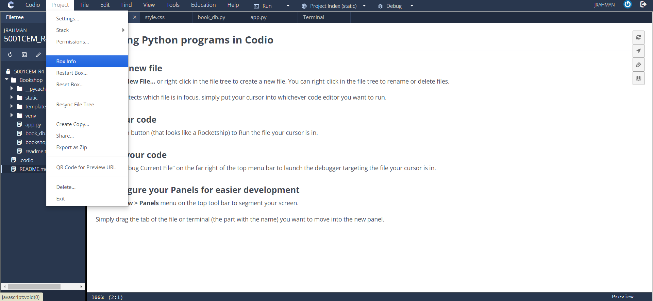

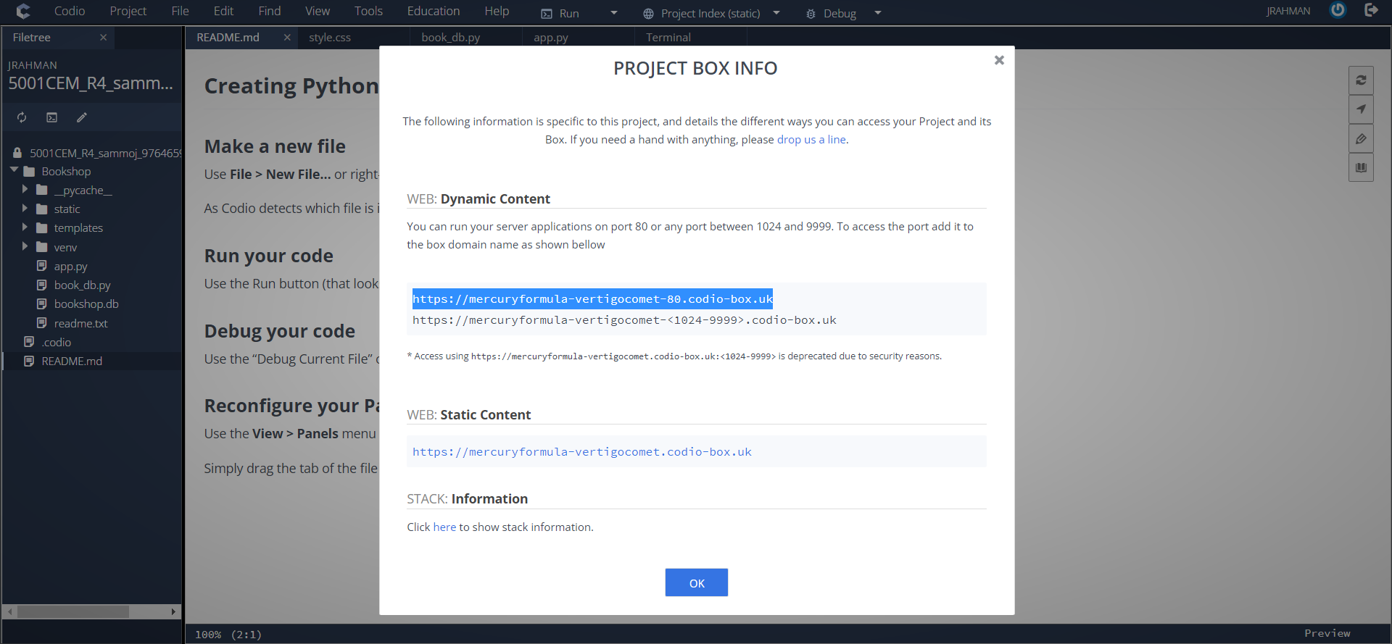

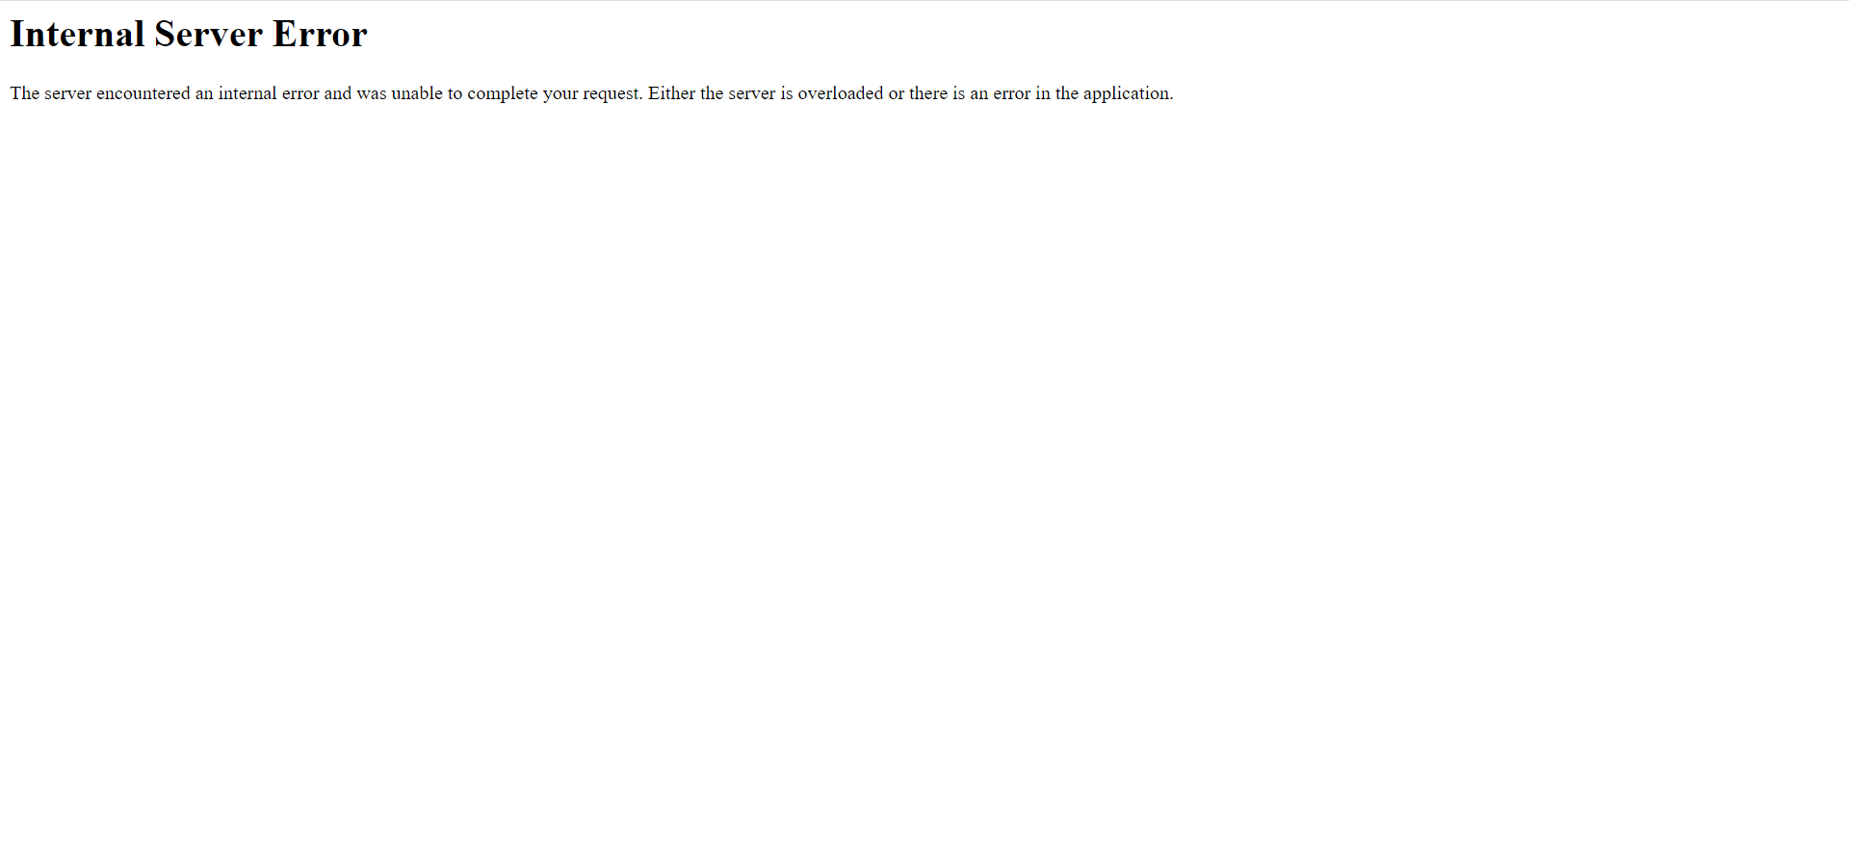

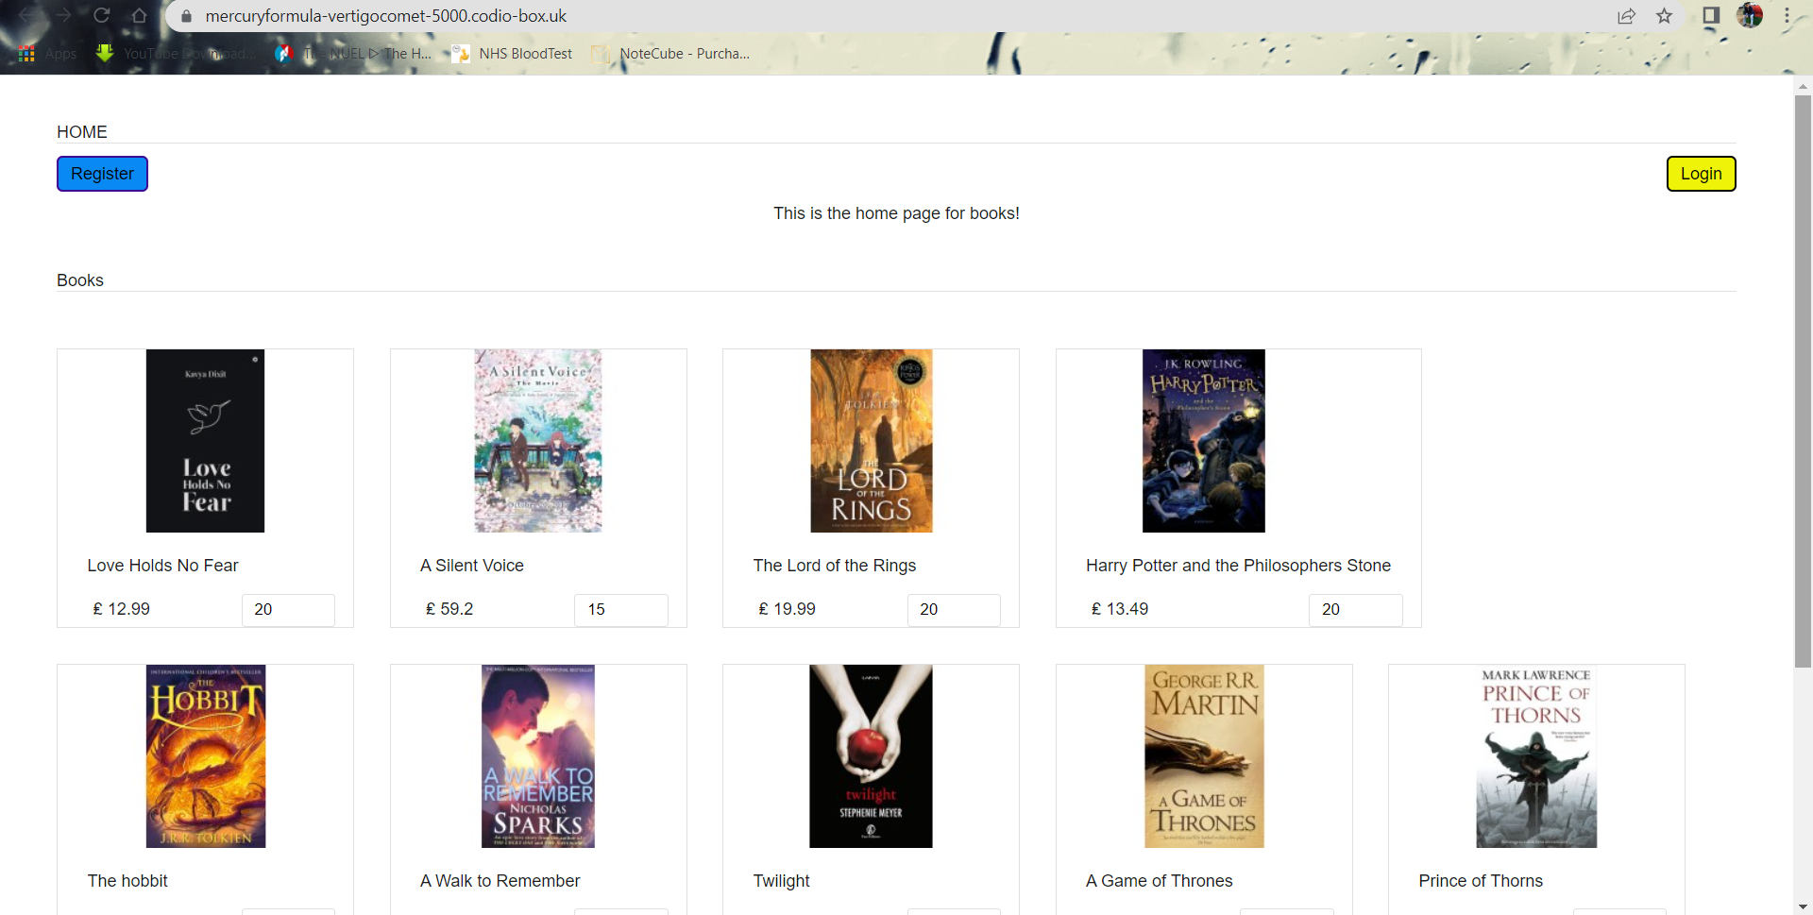

1. **CODE EXPLANATION**

The code structure is simple having two folders, templates and static, plus python files book_db.py and app.py. The file book_db.py creates the required database and app.py is the main application file. Templates has template files that displays the data in the browser. Static has a css subfolder to handle styling as well as an images subfolder which contains book images. The checkout is handled in this code along with the postage-cost. The payment system uses dummy payment method which can be replaced and integrated with Aalto payment system.

The directories in this project:

* **static:** this folder contains the static files, such as the style handler file and images.
* **template:** this folder contains the HTML template files.
* **venv:** the venv folder is for the virtual environment related files.
* **app.py:** the main file for the application which initializes the application, defines all interfaces and routes the functionalities.
* **book_db.py:** this file builds the bookshop database which initializes the database for the server.
* **bookshop.db:** this is the sqlite3 database file which contains data for the books as well as the users. Establishes and maintains connection with the application server in order to display and use the data from the database.

The commented code along with explanation:

**book_db.py –**

The following code builds a database for bookshop with record for 10 books:

'''

INITIALIZE DATABASE

Connection to database

Create tables in database

'''

**from** flask **import** Flask

**from** flask **import** render_template

**import** sqlite3

# create the database file

con **=** sqlite3.connect('bookshop.db')

# create books table

con.execute('CREATE TABLE books(bookname VARCHAR(255) NOT NULL, author VARCHAR(255) NOT NULL, date DATETIME NOT NULL, ISBN int unsigned NOT NULL UNIQUE PRIMARY KEY, description TEXT, image TEXT NOT NULL, trade_price DOUBLE NOT NULL, retail_price DOUBLE NOT NULL, quantity int)')

con.close()

# connect to database

con **=** sqlite3.connect('bookshop.db')

# insert data to books table

con.execute('INSERT INTO books(bookname, author, date, ISBN, description, image, trade_price, retail_price, quantity) VALUES ("Love Holds No Fear", "Kavya Dixit", "2020-11-18", 9781636697000, "...", "book-images/lovefear.jpg", 12.99, 9.99, 20),("A Silent Voice", "Yoshitoki Ōima", "2014-10-17", 9781632360595, "...", "book-images/silentvoice.jpg", 59.20, 49.99, 15),("The Lord of the Rings", "J. R. R. Tolkien", "1954-07-29", 9780007141326, "...", "book-images/lordrings.jpg", 19.99, 14.99, 20),("Harry Potter and the Philosophers Stone", "J. K. Rowling", "1997-06-26", 9780747532743, "...", "book-images/harrypotter1.jpg", 13.49, 9.99, 20),("The hobbit", "J. R. R. Tolkien", "1937-09-21", 9780547928227, "...", "book-images/hobbit.jpg", 11.91, 7.99, 20),("A Walk to Remember", "Nicholas Sparks", "1999-10-19", 9780446608954, "...", "book-images/walk.jpg", 8.33, 4.99, 20),("Twilight", "Stephenie Meyer", "2005-10-05", 9780316015844, "...", "book-images/twilight.jpg", 14.30, 9.99, 20),("A Game of Thrones", "George R. R. Martin", "1996-08-01", 9780006479888, "...", "book-images/gamethrones.jpg", 16.78, 9.99, 20),("Prince of Thorns", "Mark Lawrence", "2011-08-02", 9781937007683, "...", "book-images/princethorns.jpg", 8.99, 4.99, 15),("The Diary of a Young Girl", "Anne Frank", "1947-06-25", 9780553296983, "...", "book-images/thedairy.jpg", 9.99, 5.99, 20);')

# commit to database

con.commit()

con.close()

# connect to database

con **=** sqlite3.connect('bookshop.db')

# create users table

con.execute('CREATE TABLE users(id INTEGER PRIMARY KEY AUTOINCREMENT NOT NULL, username TEXT, pwd PASSWORD)')

con.close()

# connect to database

con **=** sqlite3.connect('bookshop.db')

# insert data into users table

con.execute('INSERT INTO users(username, pwd) VALUES ("admin", "p455w0rd"),("customer1", "p455w0rd"),("customer2", "p455w0rd");')

# commit to database

con.commit()

con.close()

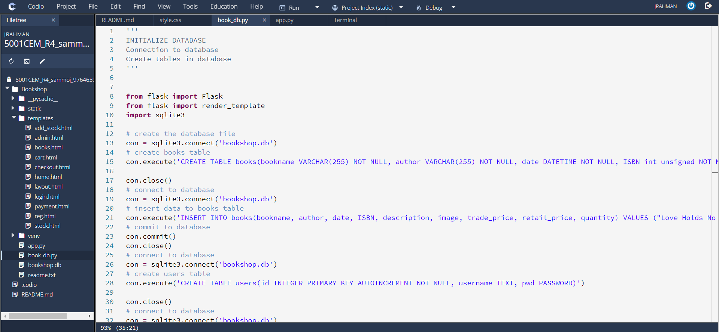

The database creates table for books and users. The books table has ten records for books and the user tables has three user data recorded, one of the records is for admin while other two is customer record. The file creates a bookshop database and checks for existing table before creating new one. If table already exists, then it adds records to the tables. We are using the sqlite3 database system.

**bookshop.db –**

This is the file which contains the database. The data is stored in this file and can be accessed by the application. This database has two tables. The books table holds record for existing books and newly added books. The user table contains the record for existing users and newly added users. First, it is checked if the database exists otherwise, we need to create the database using book_db.py then proceed with the next steps. Then the values are inserted into the database which are ten records for the books table and three record for users table. The database establishes the connection with application and provides the data required.

**static –**

The static folder holds the style handler files and images. The style.css file changes the style of HTML templates which controls how a page would be shown or how the form is going to appear. It can specify borders, margins, alignment, colour, font, size, height, width, padding, decoration, cursor, table etc. These specify the HTML pages which would get rendered by the application file. The book images folder contains existing book image and displays them when the file path calls for it and adds new images when a new book is added.

/* style.css file controls all the related HTML files from template folder */

**body** {

    font-family: Arial;

    color: #211a1a;

    font-size: 0.9em;

}

#home {

    margin: 40px;

}

#book-grid {

    margin: 40px;

}

#book-cart {

    margin: 40px;

}

#book-cart **table** {

    width: 100%;

    background-color: #F0F0F0;

}

#book-cart **table** **td** {

    background-color: #FFFFFF;

}

.txt-heading {

    color: #211a1a;

    border-bottom: 1px solid #E0E0E0;

    overflow: auto;

}

#btnReg {

    background-color: #0889f3;

    border: #400192 2px solid;

    padding: 5px 10px;

    color: #000000;

    float: left;

    text-decoration: none;

    border-radius: 5px;

    margin: 10px 0px;

}

#btnLogin {

    background-color: #eff308;

    border: #000000 2px solid;

    padding: 5px 10px;

    color: #000000;

    float: right;

    text-decoration: none;

    border-radius: 5px;

    margin: 10px 0px;

}

#btnLogout {

    background-color: #f3a908;

    border: #000000 2px solid;

    padding: 5px 10px;

    color: #000000;

    float: left;

    text-decoration: none;

    border-radius: 5px;

    margin: 10px 0px;

}

#btnShop {

    background-color: #e3f308;

    border: #000000 2px solid;

    padding: 5px 10px;

    color: #000000;

    float: left;

    text-decoration: none;

    border-radius: 5px;

    margin: 10px 0px;

}

#btnStock {

    background-color: #ffffff;

    border: #f70757 1px solid;

    padding: 5px 10px;

    color: #f70757;

    float: right;

    text-decoration: none;

    border-radius: 3px;

    margin: 10px 0px;

}

#btnCart {

    background-color: #ffffff;

    border: #3700d0 1px solid;

    padding: 5px 10px;

    color: #1500d0;

    float: right;

    text-decoration: none;

    border-radius: 3px;

    margin: 10px 0px;

}

#btnEmpty {

    background-color: #ffffff;

    border: #d00000 1px solid;

    padding: 5px 10px;

    color: #d00000;

    float: right;

    text-decoration: none;

    border-radius: 3px;

    margin: 10px 0px;

}

#btnCheckout {

    background-color: #fafcfc;

    border: #081270 1px solid;

    padding: 5px 10px;

    color: #0fa81c;

    float: right;

    text-decoration: none;

    border-radius: 3px;

    margin: 10px 0px;

}

#btnPay {

    background-color: #25eeee;

    border: #075f7a 2px solid;

    padding: 10px 15px;

    color: #861111;

    float: right;

    text-decoration: none;

    border-radius: 3px;

    margin: 10px 0px;

}

.btnAddAction {

    padding: 5px 10px;

    margin-left: 5px;

    background-color: #efefef;

    border: #E0E0E0 1px solid;

    color: #211a1a;

    float: right;

    text-decoration: none;

    border-radius: 3px;

    cursor: pointer;

}

#book-grid .txt-heading {

    margin-bottom: 18px;

}

.book-item {

    float: left;

    background: #ffffff;

    margin: 30px 30px 0px 0px;

    border: #E0E0E0 1px solid;

}

.stock-item {

    float: left;

    background: #ffffff;

    margin: 30px 30px 0px 0px;

    border: #E0E0E0 1px solid;

}

.book-image {

    height: 155px;

    width: 250px;

    background-color: #FFF;

}

.clear-float {

    clear: both;

}

.demo-input-box {

    border-radius: 2px;

    border: #CCC 1px solid;

    padding: 2px 1px;

}

.tbl-cart {

    font-size: 0.9em;

}

.tbl-cart **th** {

    font-weight: normal;

}

.book-title {

    padding: 5px 10px;

    margin-bottom: 10px;

}

.book-price {

    padding: 5px 10px;

    margin-left: 5px;

    float:left;

}

.cart-action {

    float: right;

}

.book-quantity {

    padding: 5px 10px;

    border-radius: 3px;

    border: #E0E0E0 1px solid;

}

.book-tile-footer {

    padding: 15px 15px 0px 15px;

    overflow: auto;

}

.cart-item-image {

    width: 30px;

    height: 30px;

    border-radius: 50%;

    border: #E0E0E0 1px solid;

    padding: 5px;

    vertical-align: middle;

    margin-right: 15px;

}

.intro {

    text-align: center;

    clear: both;

    margin: 38px 0px;

}

.no-records {

    text-align: center;

    clear: both;

    margin: 38px 0px;

}

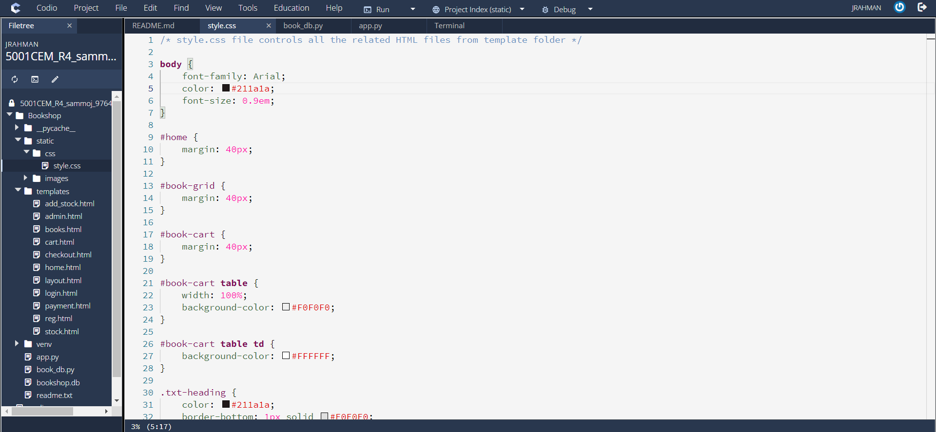

**templates –**

The templates directory contains HTML files which gets rendered when a specific file is returned. It is the main structure of how the data is being displayed by the application in a server. There are 11 HTML files for this project. The files are layout.html, home.html, books.html, reg.html, login.html, cart.html, admin.html, stock.html, add_stock.html, checkout.html and payment.html. Each of these has HTML commands which fulfils specific purposes.

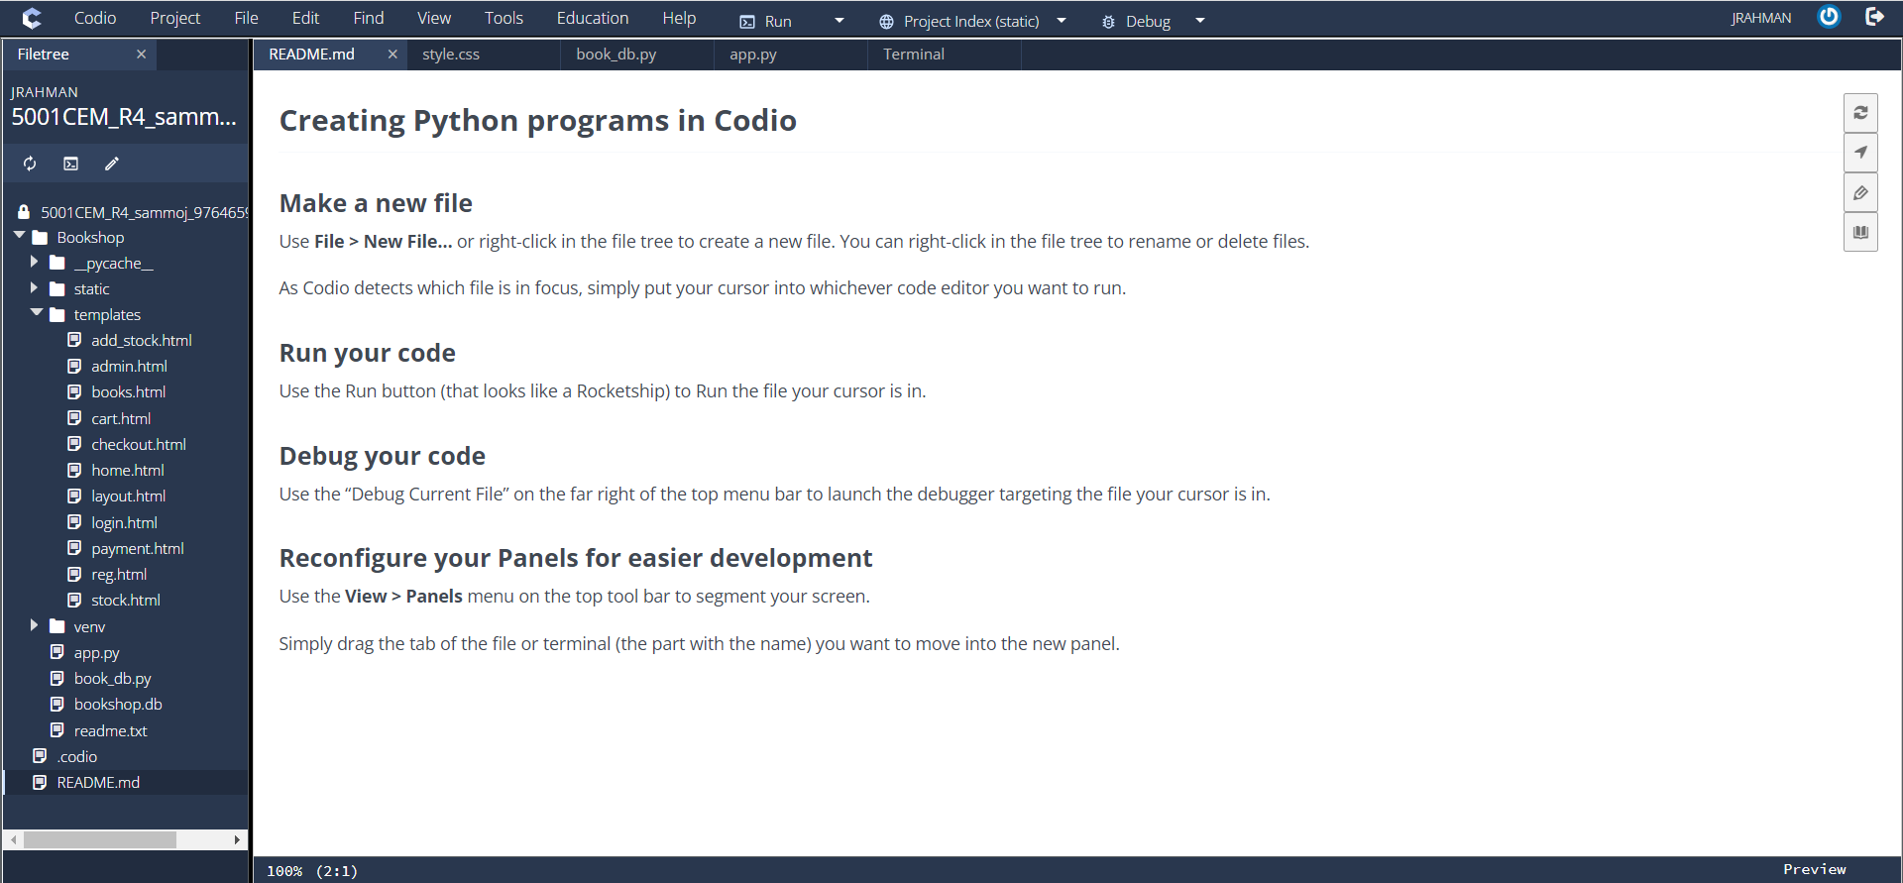

The layout.html is the base structure of these HTML files which contains the stylesheet hyper reference:

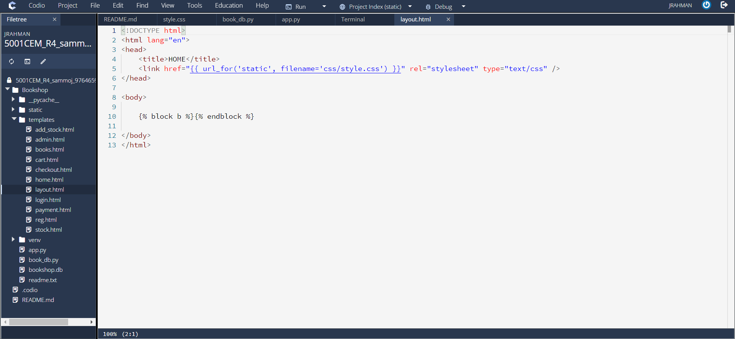

The home.html file is for the books to be displayed without having the need to login. The first and default page is shown according to this file:

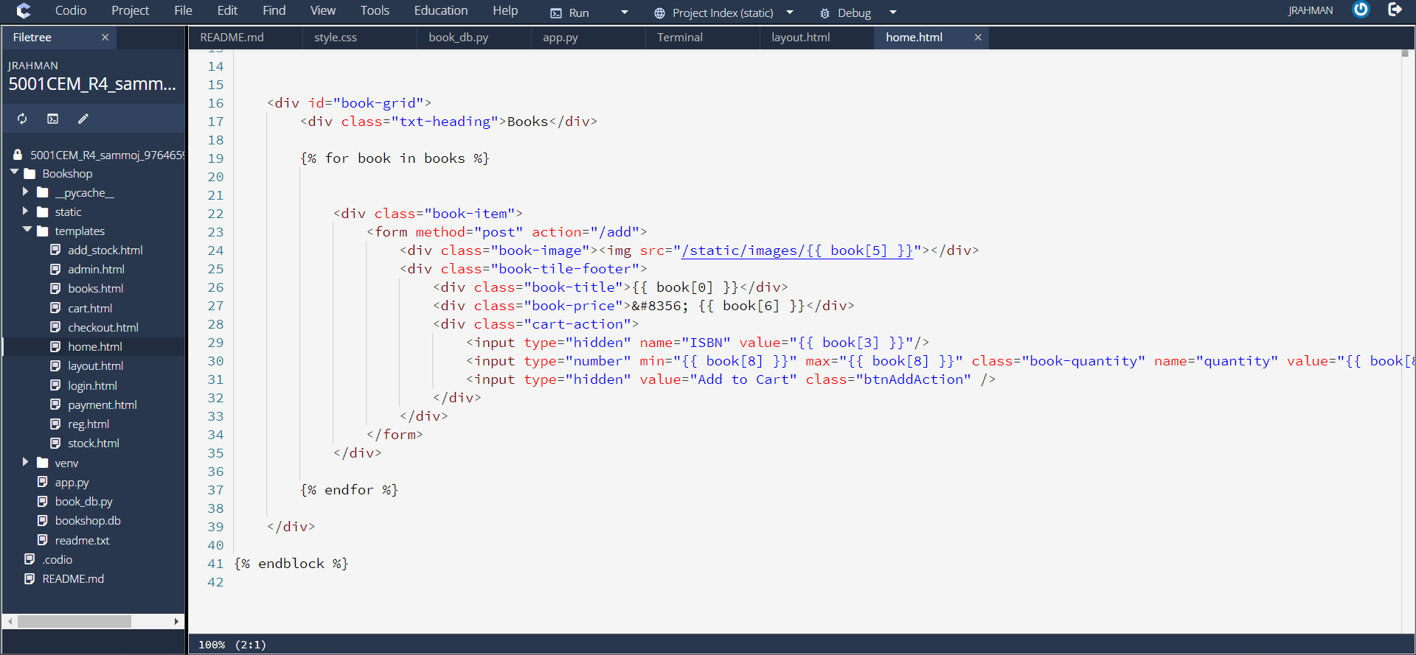

The reg.html gives structure to the registration page while the login.html structures the login page and both of the form takes username and password as input:

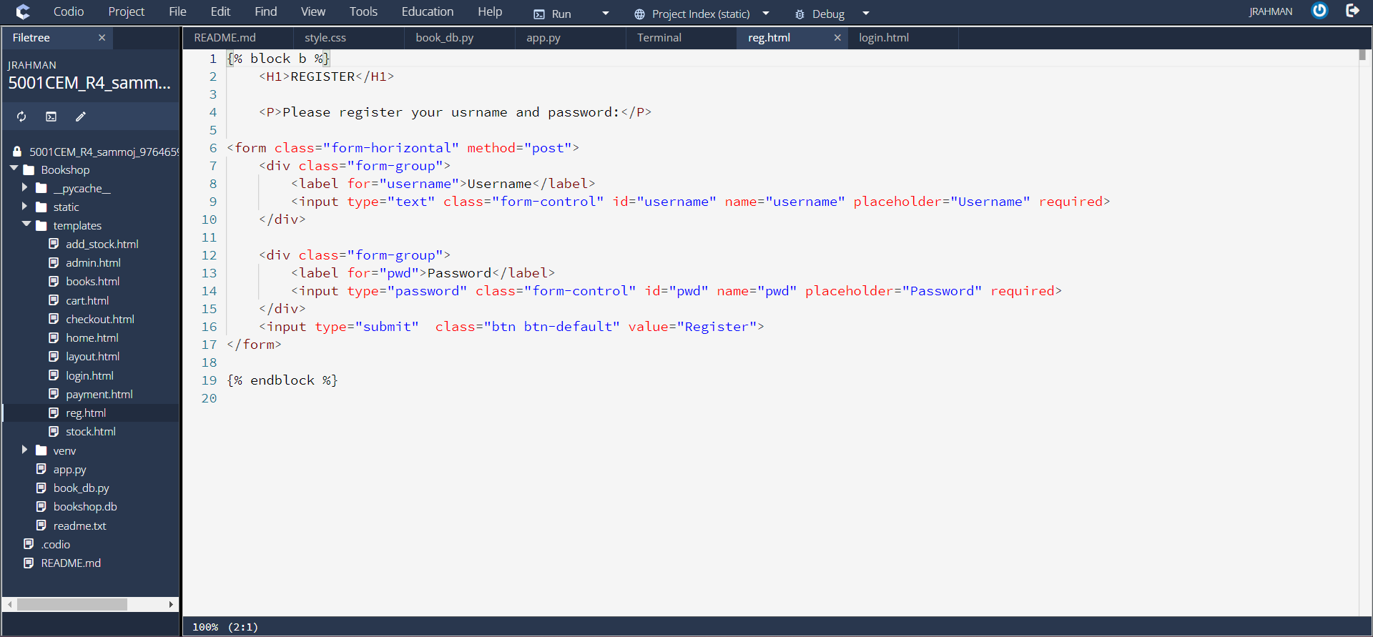

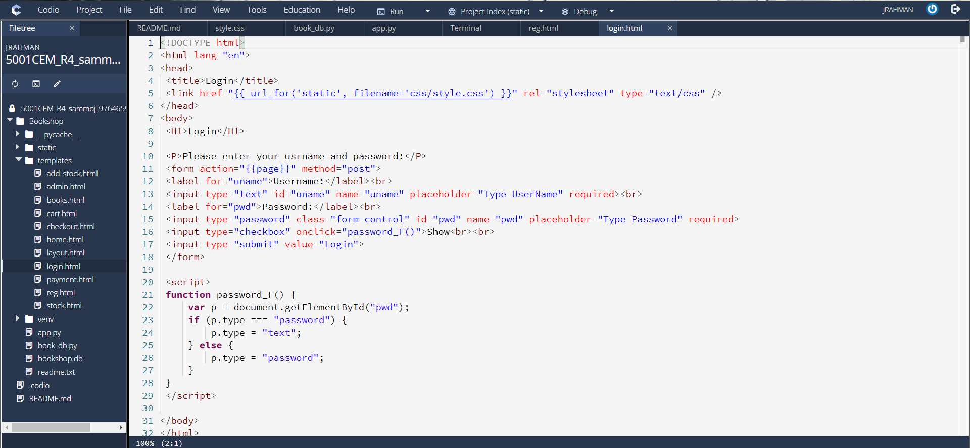

The books.html is the main structure file which forms tables for books along with details which can be taken to the cart page and be displayed by cart.html file:

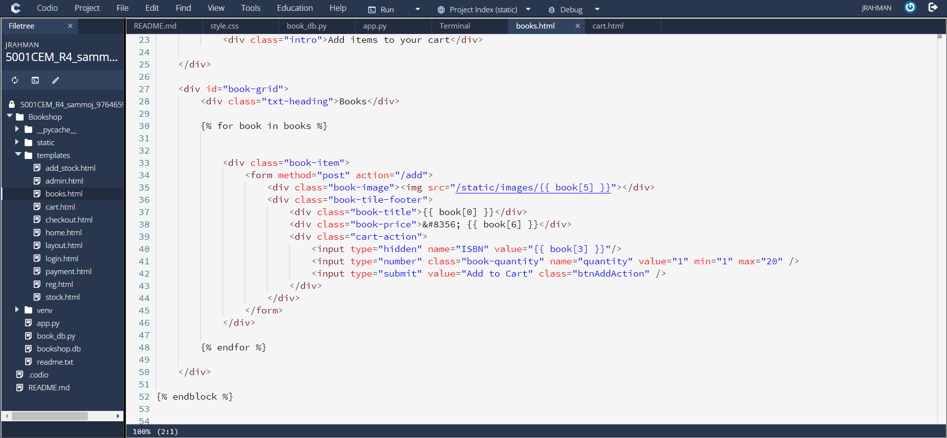

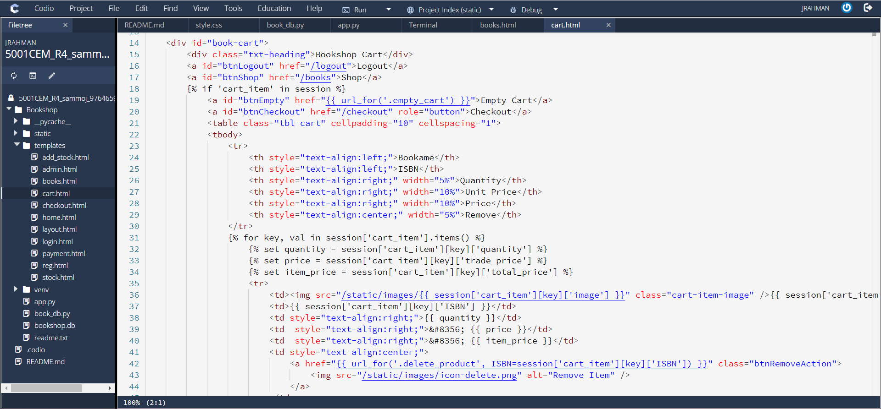

The admin.html structures the page for admin which can lead to stock.html and add_stock.html:

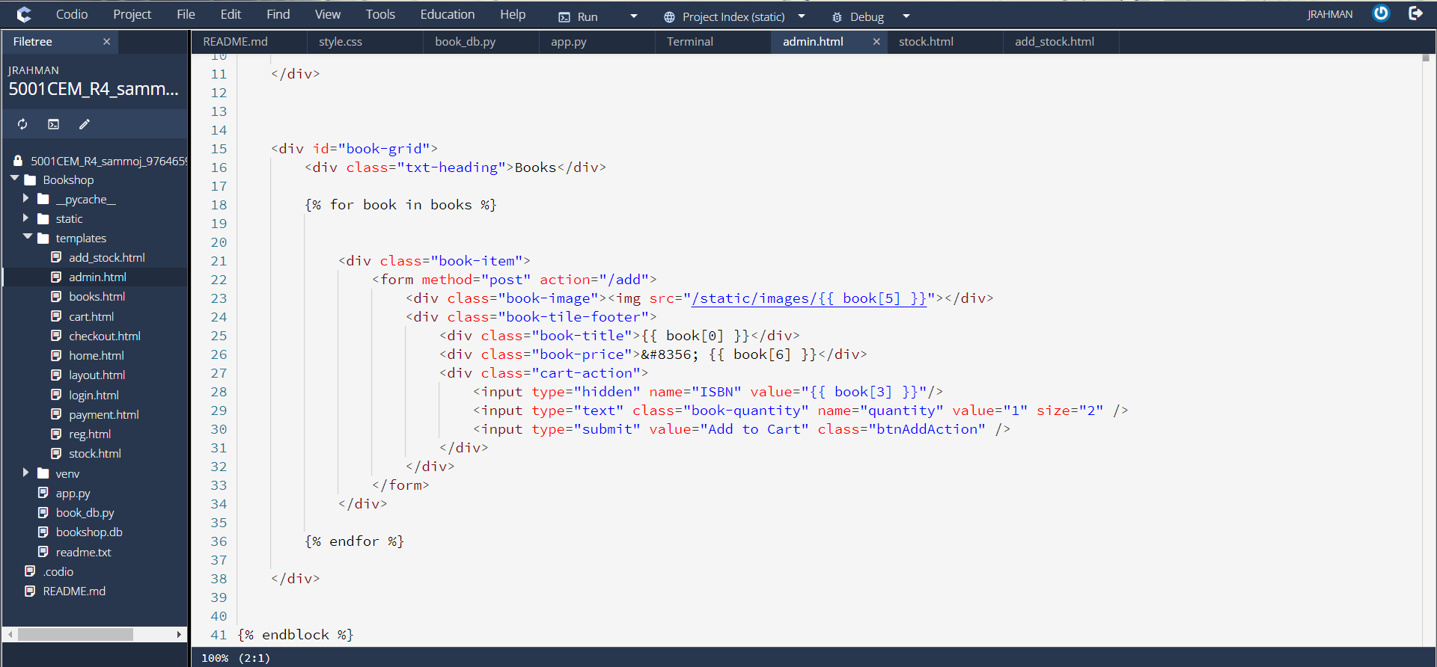

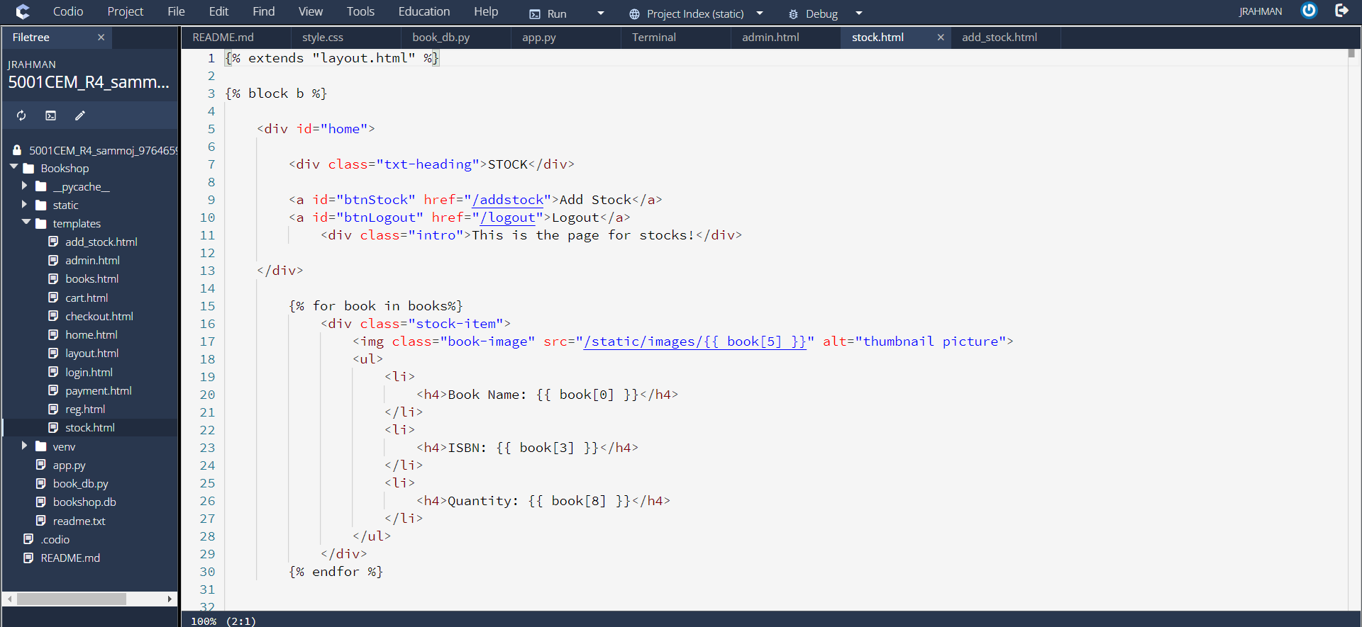

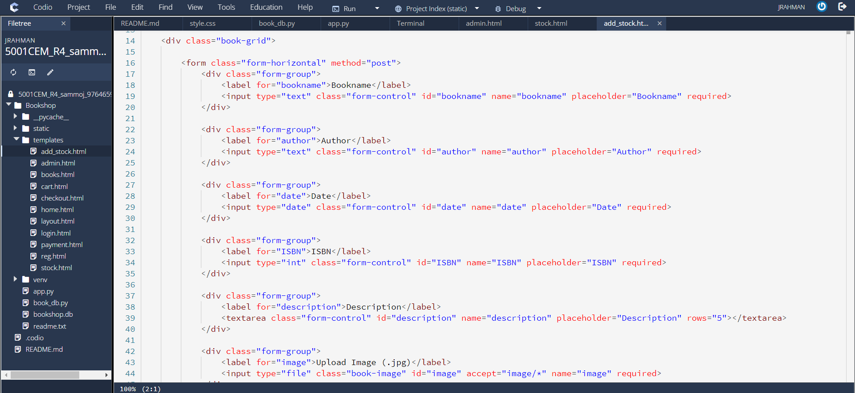

The checkout.html and payment.html are HTML files for processing the checkout and payment pages which forms necessary structure for checkout and shows dummy payment:

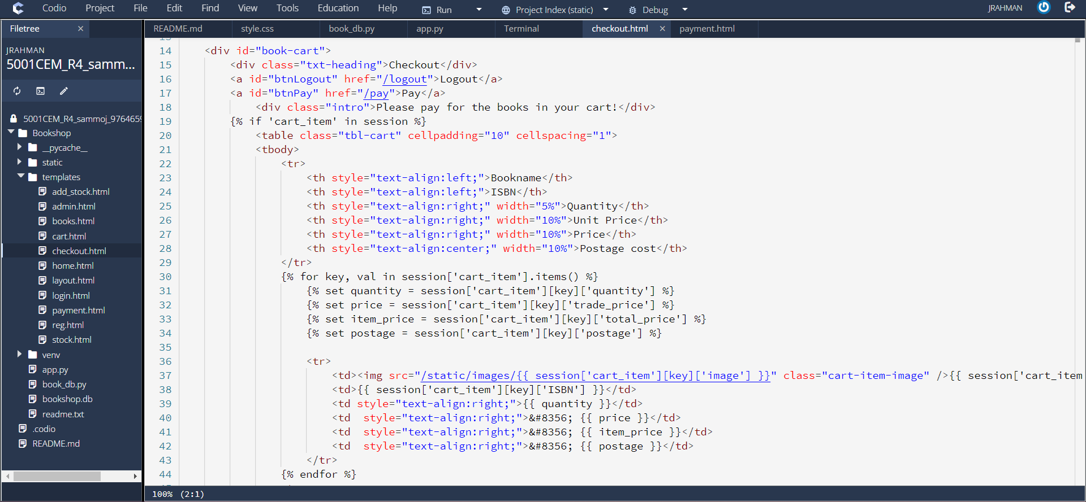

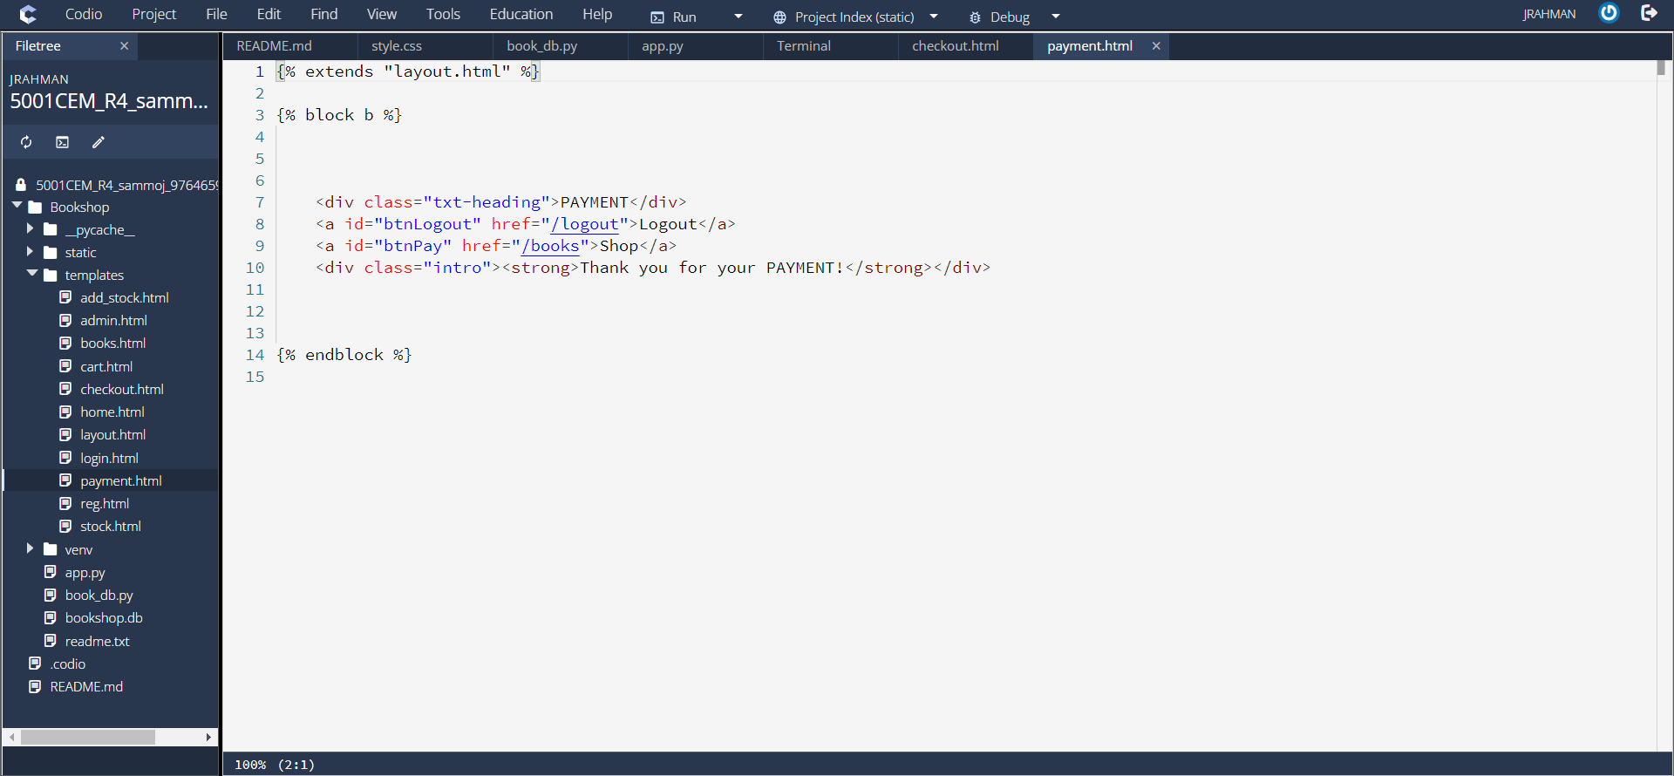

**app.py –**

This is the main application which initializes the application and defines function. The routes which are being used to display pages in the server are declared in here.

'''

The application file

'''

# Interface, function, and routes for server

# Import modules

**from** flask **import** Flask

**import** sqlite3

**from** flask **import** flash, session, url_for, render_template, request, redirect, make_response, jsonify, send_from_directory

**from** flask_session **import** Session

**from** werkzeug.security **import** generate_password_hash, check_password_hash

**from** passlib.apps **import** custom_app_context **as** pwd_context

**from** tempfile **import** gettempdir

**import** datetime

**import** os

**from** werkzeug.utils **import** secure_filename

# configure the application

app **=** Flask(__name__)

# set the secret key to random string

app.secret_key **=** "its secret!"

# configure session application

app.config["SESSION_FILE_DIR"] **=** gettempdir()

app.config["SESSION_PERMANENT"] **=** **False**

app.config["SESSION_TYPE"] **=** "filesystem"

Session(app)

Here, different modules have been imported such as flask, sqlite3, session, datetime, os etc to setup the files to run using those modules.

'''

START

Input: None

Output: Books in the database

Return the books list

'''

*@app.route*('/')

*@app.route*('/home')

**def** **home**():

    # This is the home page which displays items in the bookshop.

**try**:

        # connects to the bookshop.db database

        con **=** sqlite3.connect('bookshop.db')

        # set cursor for the connection

        cur **=** con.cursor();

        # execute SQL statement

        cur.execute("SELECT * FROM books")

        # fetch all rows for the query

        rows **=** cur.fetchall()

        # render home.html layout

        # books tables is fetched by rows query

**return** render_template('home.html', books**=**rows)

**except** Exception **as** e:

        # defines the argument as except statement

**print**(e)

**finally**:

        cur.close()

        con.close()

This function is defined as home which is the first function that connects to the database and fetches the records from the books table which is displayed in rows in the home page. This function returns books table in rows and renders it in home.html file. There are two routes for this function. The default route, @app.route('/') calls this function while /home URL also does the same.

'''

REGISTER

Input: username and pwd

Output: Register user in users table

Implements registration with POST method

'''

*@app.route*('/register', methods**=[**'GET', 'POST'**]**)

**def** **register**():

    # if user reached route via POST

**if** request.method **==** 'POST':

        # if username and pwd was submitted

**return** do_the_registration(request.form['username'], request.form['pwd'])

**else**:

        # if user reacher route via GET

**return** show_the_registration_form();

**def** **show_the_registration_form**():

    # render reg.html for page register

**return** render_template('reg.html',page**=**url_for('register'))

**def** **do_the_registration**(u,p):

    # connect to database

    con **=** sqlite3.connect('bookshop.db')

    # execute statement; register username and password to the database

    con.execute("INSERT INTO users(username, pwd) VALUES(?,?);", (u, p))

    # commit to the database

    con.commit()

    # closes the connection

    con.close()

    # returns the defined function which shows the login form

**return** show_the_login_form()

The function is defined as register which processes the registration. The form gets the inputs username and password which is passed as POST method. If the username and password has been submitted properly it passes to do_the_registration(u,p) function with username as u and password as p parameter and the data is inserted into the database to register the user. After the registration is finished the server returns to the login page where the login function is called.

'''

LOGIN

Input: username and pwd

Output: login using users table

Implements the login with POST method

'''

*@app.route*('/login', methods**=[**'GET', 'POST'**]**)

**def** **login**():

    # if user reached route via POST

**if** request.method **==** 'POST':

        # User log in by submitted form data

**try**:

            # if username was submitted

            username **=** request.form["uname"]

            # if password was submitted

            password **=** request.form["pwd"]

            # if username and password is the admin

**if** username **==** "admin" **and** password **==** "p455w0rd":

                # start session

                session["id"] **=** 0

                # session is admin

                session["username"] **=** "admin"

                # redirect to admin page

**return** redirect('/admin')

**else**:

                # if user not admin then login to database

**return** do_the_login(request.form['uname'], request.form['pwd'])

**except** Exception **as** e:

**print**(e)

    # else if user reached route via GET

**else**:

        # return the function

**return** show_the_login_form()

**def** **show_the_login_form**():

    # render login.html page for login

**return** render_template('login.html',page**=**url_for('login'))

**def** **do_the_login**(u,p):

    # clears all session

    session.clear()

    # connect database

    con **=** sqlite3.connect('bookshop.db')

    cur **=** con.cursor();

    # execute stament; login to the server; query database for username and pwd

    cur.execute("SELECT count(*) FROM users WHERE username=? AND pwd=?;", (u, p))

**if**(**int**(cur.fetchone()**[**0**]**))**>**0:

        flash("Welcome!")

        # redirect to books page

**return** redirect(url_for('.books'))

**else**:

        # redirect to home page

**return** redirect('/home')

The function checks the database for existing users to log the user in. The login.html file shows the login form and asks the user for username and password. If username and password is submitted, then it passes as POST method and matches the database records. If the user is admin then it redirects to admin page.

'''

ADMIN

Input: 'admin' username

Output: admin.html

Returns the admin page

'''

*@app.route*('/admin')

**def** **admin**():

    # if user is admin

**if** session **is** **not** **None** **and** 'username' **in** session **and** session['username'] **==** 'admin':

**try**:

            # connect database

            con **=** sqlite3.connect('bookshop.db')

            cur **=** con.cursor();

            # execute statement; select all from books table

            cur.execute("SELECT * FROM books")

            # query fetch all rows

            rows **=** cur.fetchall()

            # render admin.html

**return** render_template('admin.html', books**=**rows)

**except** Exception **as** e:

**print**(e)

**finally**:

            cur.close()

            con.close()

    # if user is not admin

**else**:

        # return to login page

**return** redirect('/login')

The admin function uses the admin.html to display the admin page. If the user successfully passes as an admin then it shows the current books table in rows after connecting to the database. There is a stock button which lead to the stock page to check the current stock of books.

'''

STOCK

Input: None

Output: Book list

Return the stock for books table

'''

*@app.route*("/stock", methods**=[**"GET", "POST"**]**)

**def** **stock**():

    # if session is 'admin'

**if** session **is** **not** **None** **and** 'username' **in** session **and** session['username'] **==** 'admin':

**try**:

            # connect to database

            con **=** sqlite3.connect('bookshop.db')

            cur **=** con.cursor();

            # select all from books table

            cur.execute("SELECT * FROM books")

            # fetch all rows

            rows **=** cur.fetchall()

            # show the stock.html file as render

**return** render_template("stock.html", books**=**rows)

**except** Exception **as** e:

**print**(e)

**finally**:

            cur.close()

            con.close()

**else**:

        # redirect to admin page

**return** redirect('/admin')

The stock page renders stock.html and shows books as rows. The following page is shown:

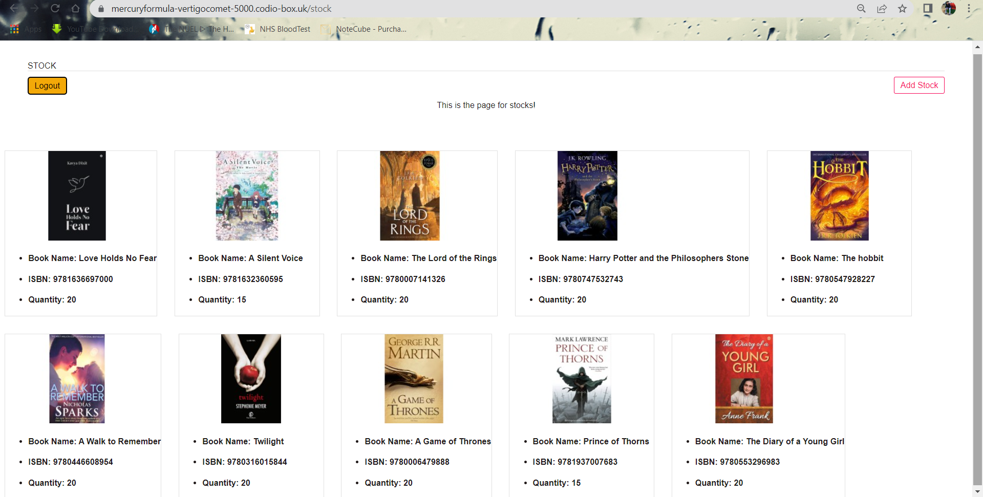

From this page, the admin can go to the add stock page which is formed by add_stock.html where admin can add more books to the stock.

'''

ADD STOCK PAGE

input: bookname, author, date, ISBN, description, image, trade_price, retail_price, quantity

output: add new book to database

Implement adding new books to stock

'''

*@app.route*('/addstock', methods**=[**'GET', 'POST'**]**)

**def** **add_stock**():

**if** request.method **==** 'POST':

        # if bookname, author, date, ISBN, description, image, trade_price, retail_price, quantity was submitted

**return** do_add_stock(request.form['bookname'], request.form['author'], request.form['date'], request.form['ISBN'], request.form['description'], request.files['image'], request.form['trade_price'], request.form['retail_price'], request.form['quantity'])

**else**:

        # return the function for add stock form

**return** show_add_stock_form();

**def** **show_add_stock_form**():

    # render add_stock.html template file and page url is add_stock

**return** render_template('add_stock.html',page**=**url_for('add_stock'))

**def** **do_add_stock**(bookname,author,date,ISBN,description,image,trade_price,retail_price,quantity):

**try**:

        # connect to database

        con **=** sqlite3.connect('bookshop.db')

        cur **=** con.cursor();

        # check if ISBN is 13 digits

**if** ISBN **is** **not** **None** **and** **len**(ISBN) **==** 13:

            # select quantity for specific book ISBN

            cur.execute("SELECT quantity FROM books WHERE ISBN = ?;", (ISBN))

            # fetch one row

            row **=** cur.fetchone()

            # ensures row is present

**if** row **is** **not** **None**:

                # quantity is sum of existing quantity and new quantity

                qty **=** row[0] **+** **int**(quantity)

                # updates the books table for quantity

                cur.execute("UPDATE books SET quantity = ? WHERE ISBN = ?;", (qty, ISBN))

                con.commit()

                cur.close()

                con.close()

                # returns the stock page

**return** redirect('/stock')

**else**:

                # save the uploaded image

                image.save(os.path.join('static/images', image.filename))

                # insert new book data

                cur.execute("INSERT INTO books(bookname, author, date, ISBN, description, image, trade_price, retail_price, quantity) VALUES (?, ?, ?, ?, ?, ?, ?, ?, ?);", (bookname, author, date, ISBN, description, image, trade_price, retail_price, quantity))

                con.commit()

                con.close()

                # returns the stock page

**return** redirect('/stock')

**else**:

            # render add_stock.html page

**return** render_template("add_stock.html")

**except** Exception **as** e:

**print**(e)

**finally**:

        cur.close()

        con.close()

The form asks for book details which will be added as new stock to the books table. There are 9 fields (bookname, author, date, ISBN, description, image, trade_price, retail_price and quantity) where user needs to input value to add a book. If the book already exists in the database then it adds the quantity in the stock. If a new book is given input, then it gets added in the database and gets displayed in the stock page as well as the home and books page. The database is updated after adding new stock then the page redirects to the stock page to view the current stock.

'''

BOOKS

Input: None

Output: Bookshop database

Returns the books in bookshop database

'''

*@app.route*('/books')

**def** **books**():

    # SHOW BOOKS IN THE DATABASE!

**try**:

        # connect to database

        con **=** sqlite3.connect('bookshop.db')

        cur **=** con.cursor();

        # select all from books table

        cur.execute("SELECT * FROM books")

        # fetch all rows from books table

        rows **=** cur.fetchall()

        # render books.html page

**return** render_template('books.html', books**=**rows)

**except** Exception **as** e:

**print**(e)

**finally**:

        cur.close()

        con.close()

If a user logs in and it is not admin but a customer account which matches the database records, then the books page is displayed using the /books interface which is structured by books.html. The database connects to the server and selects all from the books tables and displays all the records in rows. This is what we see after executing the code:

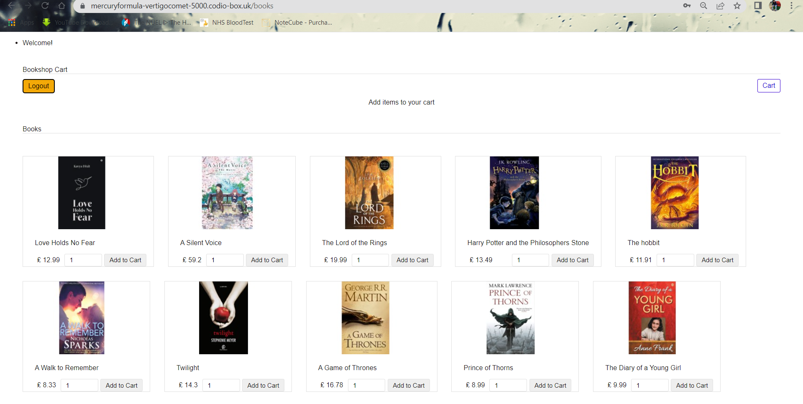

The user can add books to cart to purchase it. After adding the books to cart, the cart button takes the user to the cart page which is maintained by the cart.html file.

'''

BOOKSHOP CART

GET: get cart data

POST: add book to cart

'''

*@app.route*('/add', methods**=[**'POST', 'GET'**]**)

**def** **add_books_to_cart**():

    cursor **=** **None**

**try**:

        # if ISBN was submitted

        ISBN **=** request.form['ISBN']

        # if quantity was submitted

        quantity **=** **int**(request.form['quantity'])

        # if method is POST

**if** request.method **==** 'POST':

            # connect to database

            con **=** sqlite3.connect('bookshop.db')

            cur **=** con.cursor();

            # select all from books table for given ISBN

            cur.execute("SELECT * FROM books WHERE ISBN = ?;", **[**ISBN**]**)

            # fetch one row

            row **=** cur.fetchone()

            # create an item array

            itemArray **=** { row[3] : {'bookname' : row[0], 'ISBN' : row[3], 'quantity' : quantity, 'trade_price' : row[6], 'image' : row[5], 'total_price' : quantity **\*** row[6], 'postage' : quantity **+** 2}}

            # print the array

**print**('itemArray is', itemArray)

            # sets the value to 0

            all_total_price **=** 0

            # sets the value to 0

            all_total_quantity **=** 0

            session.modified **=** **True**

            # if there is item in cart session

**if** 'cart_item' **in** session:

                # prints the session

**print**('in session')

                # checks if the row is in cart session

**if** row[3] **in** session['cart_item']:

**for** key, value **in** session['cart_item'].items():

                        # set as key

**if** row[3] **==** key:

                            # sets key for quantity

                            old_quantity **=** session['cart_item']**[**key**][**'quantity'**]**

                            # calculates total quantity

                            total_quantity **=** old_quantity **+** quantity

                            session['cart_item']**[**key**][**'quantity'**]** **=** total_quantity

                            session['cart_item']**[**key**][**'total_price'**]** **=** total_quantity **\*** row[6]

                            session['cart_item']**[**key**][**'postage'**]** **=** **float**(total_quantity **+** 2)

**else**:

                    session['cart_item'] **=** array_merge(session['cart_item'], itemArray)

**for** key, value **in** session['cart_item'].items():

                    individual_quantity **=** **int**(session['cart_item']**[**key**][**'quantity'**]**)

                    individual_price **=** **float**(session['cart_item']**[**key**][**'total_price'**]**)

                    individual_postage **=** **float**(session['cart_item']**[**key**][**'postage'**]**)

                    all_total_quantity **=** all_total_quantity **+** individual_quantity

                    all_total_price **=** all_total_price **+** individual_price **+** individual_postage

**else**:

                session['cart_item'] **=** itemArray

                # calculates final amount for quantity

                all_total_quantity **=** all_total_quantity **+** quantity

                # calculates final amount of total price

                all_total_price **=** all_total_price **+** quantity **\*** row[6] **+** (quantity **+** 2)

            session['all_total_quantity'] **=** all_total_quantity

            session['all_total_price'] **=** **float**(all_total_price)

            # redirect to books page

**return** redirect('/books')

        # if method is get

**else**:

            # redirect to home page

**return** redirect('/home')

**except** Exception **as** e:

**print**(e)

**finally**:

        cur.close()

        con.close()

The /cart interface is one of the bigger and complex part of the code which creates an item array to process the cart system. When a user wants to add a book to cart, the ISBN is passes as POST method and the quantity also. The function matches the ISBN with the database and selects all the data for the specific book. Then the record goes into the item array where it processes the bookname, quantity, price, image for the selected ISBN. The total price and postage cost is also calculated with the quantity of books. The array holds the item of the cart and does the process for all the books that are being added to the cart and does calculation of quantity, price and postage cost for each books as well as performing a sum which shows the final cost. The page structure is shown as follow:

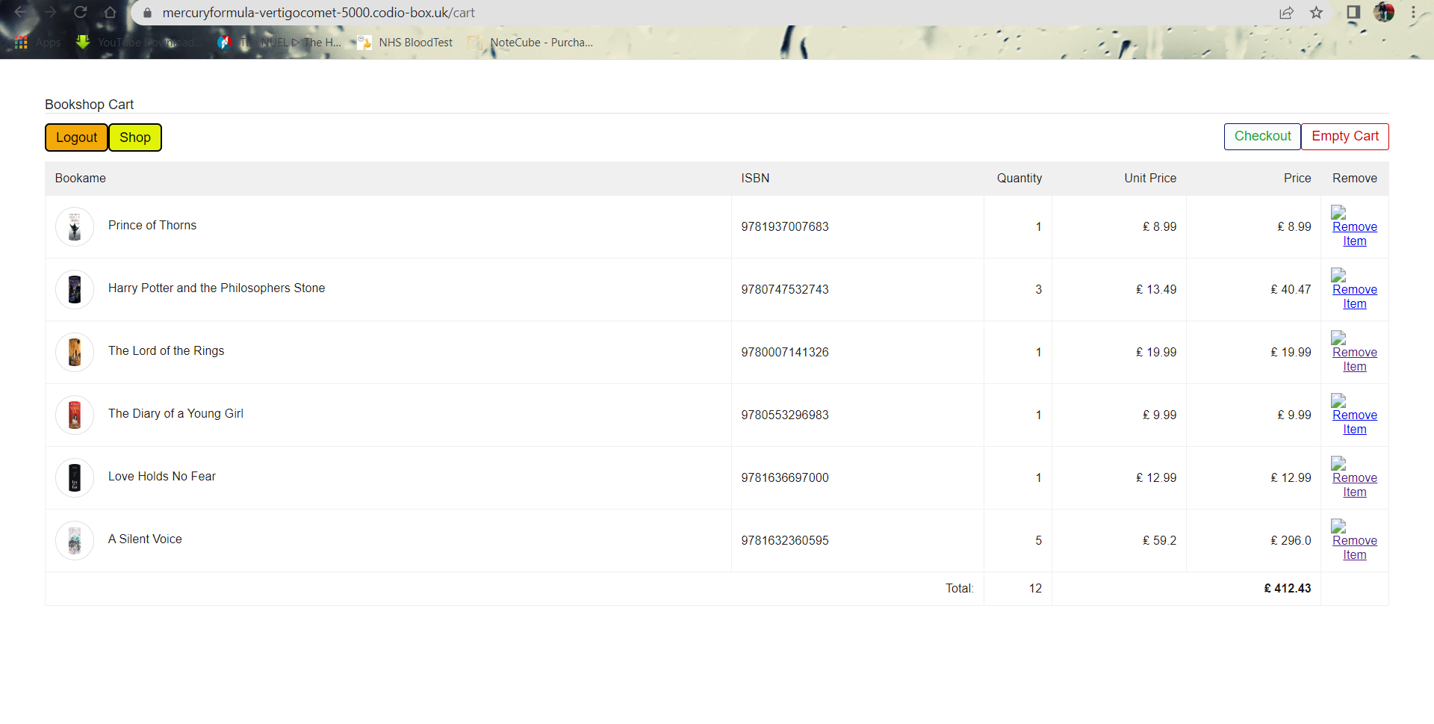

There is a shop button to go back to the books page to add more books. The remove item option removes a specific book from the list where the empty cart button removes all item from cart and redirects back to the books page.

'''

DELETE BOOK

Remove a book from cart

'''

*@app.route*('/delete/<int:ISBN>')

**def** **delete_book**(ISBN):

**try**:

        all_total_price **=** 0

        all_total_quantity **=** 0

        session.modified **=** **True**

        # get the book to remove

**for** item **in** session['cart_item'].items():

            # get the book from cart

**if** item[0] **==** ISBN:

                session['cart_item'].pop(item[0], **None**)

**if** 'cart_item' **in** session:

                    # find the cart item

**for** key, value **in** session['cart_item'].items():

                        individual_quantity **=** **int**(session['cart_item']**[**key**][**'quantity'**]**)

                        individual_price **=** **float**(session['cart_item']**[**key**][**'total_price'**]**)

                        all_total_quantity **=** all_total_quantity **+** individual_quantity

                        all_total_price **=** all_total_price **+** individual_price

**break**

        # if no book in cart, set quantity to 0

**if** all_total_quantity **==** 0:

            session.clear()

**else**:

            # remove book and set quantity and price

            session['all_total_quantity'] **=** all_total_quantity

            session['all_total_price'] **=** all_total_price

**return** redirect('/cart')

**except** Exception **as** e:

**print**(e)

This delete_book function checks for the ISBN and if it is in cart then it gets removed from the array.

'''

MERGE TWO ARRAY

'''

**def** **array_merge**( first_array , second_array ):

**if** **isinstance**( first_array , **list** ) **and** **isinstance**( second_array , **list** ):

**return** first_array **+** second_array

**elif** **isinstance**( first_array , **dict** ) **and** **isinstance**( second_array , **dict** ):

**return** **dict**( **list**( first_array.items() ) **+** **list**( second_array.items() ) )

**elif** **isinstance**( first_array , **set** ) **and** **isinstance**( second_array , **set** ):

**return** first_array.union( second_array )

**return** **False**

Then the array is merged with the existing one displaying the current cart after the remove is performed.

'''

EMPTY CART

Remove all books from cart.

'''

*@app.route*('/empty')

**def** **empty_cart**():

**try**:

        # clear the session

        session.clear()

        # redirect to books page

**return** redirect('/books')

**except** Exception **as** e:

**print**(e)

The /empty interface clears all session and removes all the books from the cart and the array is cleared which holds to data records.

'''

CHECKOUT

Input: None

Output: checkout.html

Implements the checkout system

'''

*@app.route*('/checkout')

**def** **checkout**():

    # render checkout file

**return** render_template('checkout.html')

'''

PAYMENT

Input: None

Output: payment.html

Shows the dummy payment system

'''

*@app.route*('/pay')

**def** **pay**():

    # render payment file

**return** render_template('payment.html')

These two interfaces, which are the /checkout and /payment have been kept simple and renders HTML file to do the process.

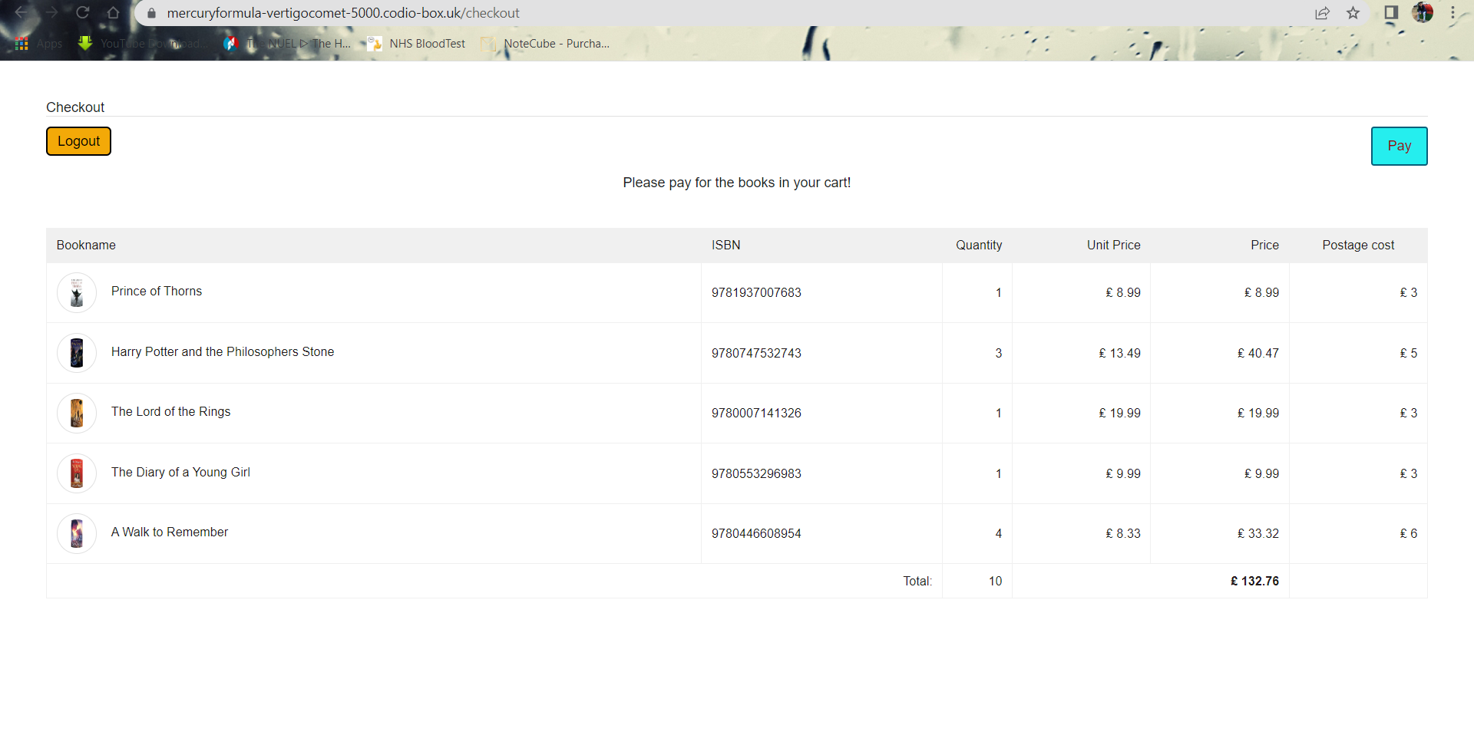

The checkout page is relayed by the cart which shows the cart items but instead of the removing option it shows the postage-cost for specific books. This can now be bought from here and taken to the payment section to pay for the items and finish the purchase order. Here the dummy payment will complete the task.

'''

LOGOUT

Input: None

Output: Home

Returns the home page

'''

*@app.route*('/logout')

**def** **logout**():

    # clear the session

    session.clear()

    # session id is None

    session["id"] **=** **None**

    # session username is None

    session["username"] **=** **None**

    # redirect to home page

**return** redirect('/home')

The /logout interface clears the user session and logs out the current user from the database. It gets redirected to the home page, from where the user can log in using existing user data or register as new user.

This completes the main part of the code, and the server performs relying on these. The app.py is the main python file which calls for different HTML page, uses the stylesheet for the HTML, fetches images, establishes connection to the database and defines interface for the user. This follows the agile method for software development and project management. The process focuses on continuous learning, planning and collaboration. The project is done by separating into small section to fulfil the client features. This helps to build the application by doing increments. The flask methodologies have been used in this project which works with python to develop a web application. The reason of using flask is, it has built-in development server and provides fast debugging. It also provides with a range of tools, technologies and libraries to use to develop a web application. There are other methodologies that can be used such as the Scrum or the Kanban.

1. **TESTING**

**Test Regime**

1. **Developer name / SID : 9764659**

**Tester name and SID : Jayed Bin Rahman Sammo (9764659)**

**2 Project**

A bookshop application with registration and login, shopfront, shopping cart, admin, checkout and dummy payment.

Customers can purchase books and admin can add more books to the stock.

The application has limited data, and no real payment facility. Security and UX are not a focus.

**3 Test scope**

Basic functional tests for each of the seven major system components:

* Home page
* Registration
* Login
* Shopfront (which is the main page for books)
* Adding to and removing from cart
* Admin
* Checkout

3.1 out of scope

The following will not be tested:

* Security
* UX

**4 Test time**

The total set of tests should take approximately forty-five minutes.

**5 Test regime**

5.1 Home (3 mins)

.1 Shows home page

Test 1: The default URL takes a user to the home page

|  |  |  |  |  |  |
| --- | --- | --- | --- | --- | --- |
| Pass | Yes | Fail | No | Comments | No issues |

Home page is shown to all users.

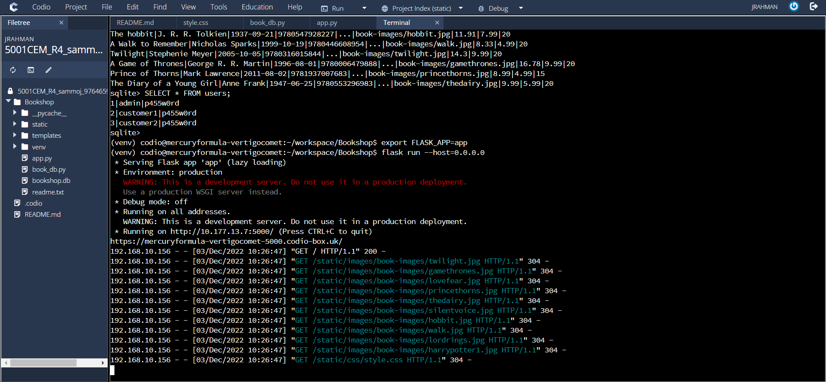 

Shows all the records.

5.2 Registration (7 mins)

1. Allows registration

Test 1: The form accepts user input, the password input is hidden

|  |  |  |  |  |  |
| --- | --- | --- | --- | --- | --- |
| Pass | Yes | Fail | No | Comments | The register button takes the user to the registration page. |

1. Register a new user

Test 1: The database accepts the user data

|  |  |  |  |  |  |
| --- | --- | --- | --- | --- | --- |
| Pass | Yes | Fail | No | Comments | No error and redirects to login page. |

1. Duplicate user data

Test 1: The database shows error for existing user data

|  |  |  |  |  |  |
| --- | --- | --- | --- | --- | --- |
| Pass | No | Fail | Yes | Comments | No error is shown and continues to login page as usual. |

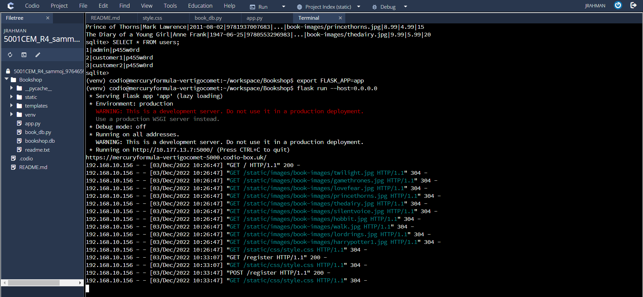 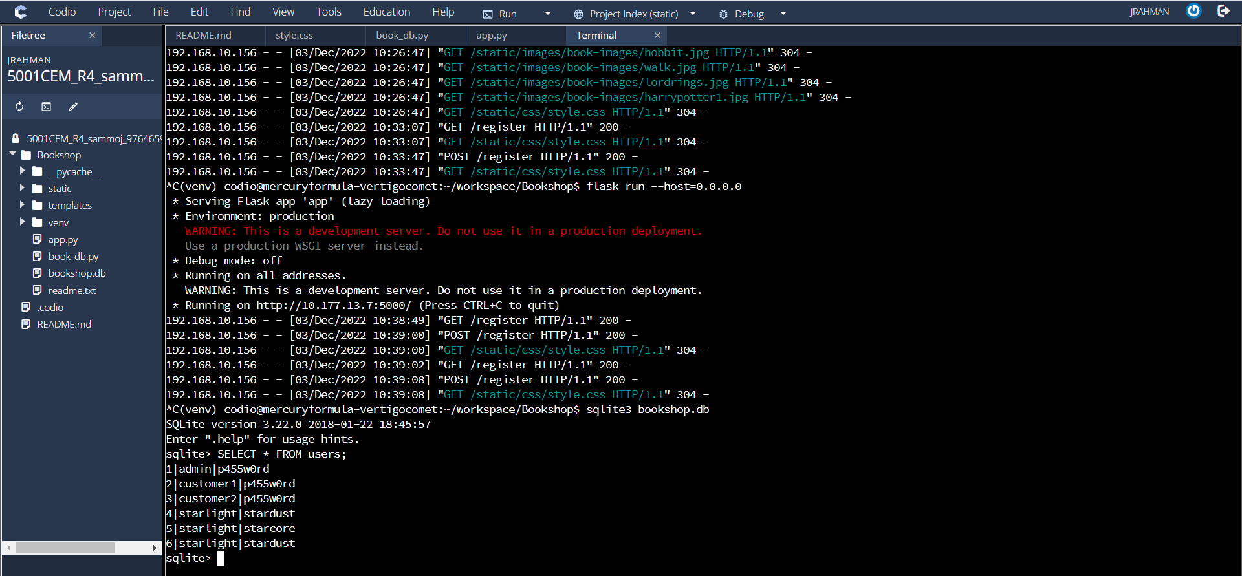 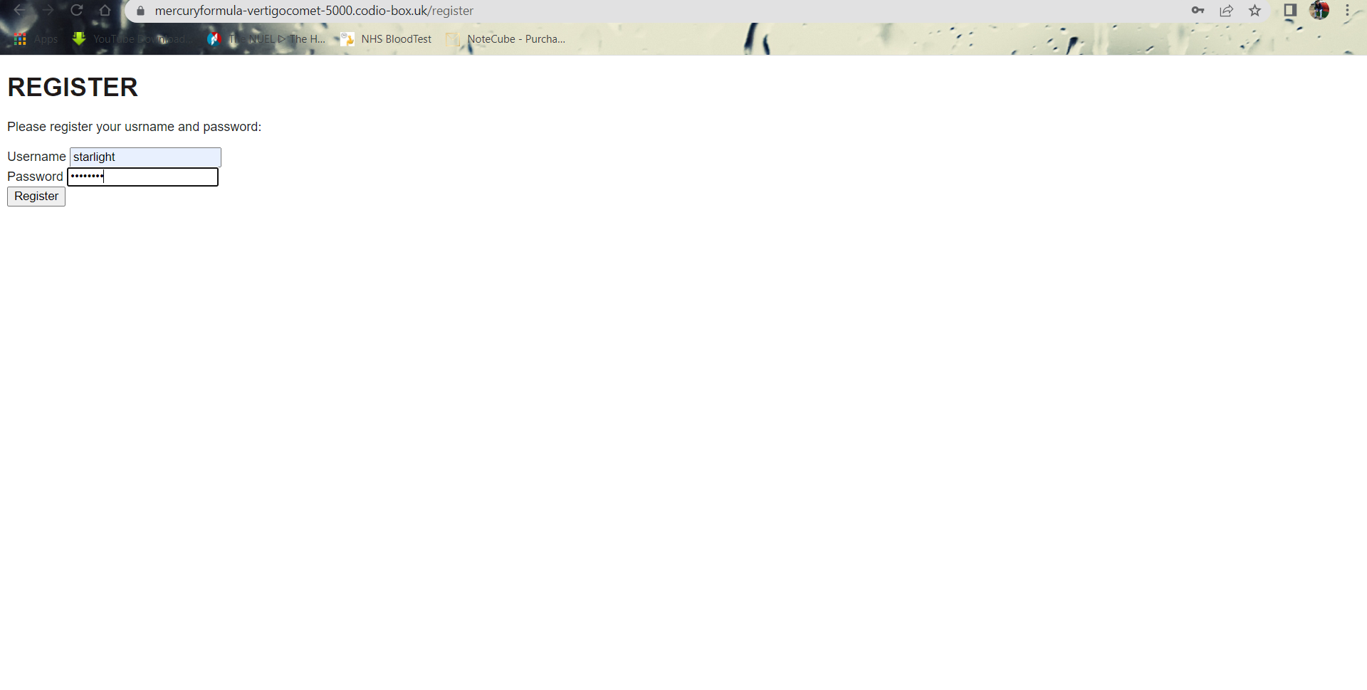

The user can register using username and password.

5.3 Login (5 mins)

.1 Allows login

Test 1: The form accepts input for username and password

|  |  |  |  |  |  |
| --- | --- | --- | --- | --- | --- |
| Pass | Yes | Fail | No | Comments | A user can use the login button to go to the login page if already registered with the database. |

.2 Use user data to do the login

Test 1: A registered user can login

|  |  |  |  |  |  |
| --- | --- | --- | --- | --- | --- |
| Pass | Yes | Fail | No | Comments | No error and redirects to main page for books. |

.3 Login with incorrect password

Test 1: Can’t login with incorrect password

|  |  |  |  |  |  |
| --- | --- | --- | --- | --- | --- |
| Pass | Yes | Fail | No | Comments | Redirects to home page. |

.4 Login with no existing user

Test 1: A user can’t login without being registered

|  |  |  |  |  |  |
| --- | --- | --- | --- | --- | --- |
| Pass | Yes | Fail | No | Comments | Redirects to home page. |

.5 Login with admin

Test 1: Logs the user into the admin account

|  |  |  |  |  |  |
| --- | --- | --- | --- | --- | --- |
| Pass | Yes | Fail | No | Comments | Admin account is redirected to the admin page. |

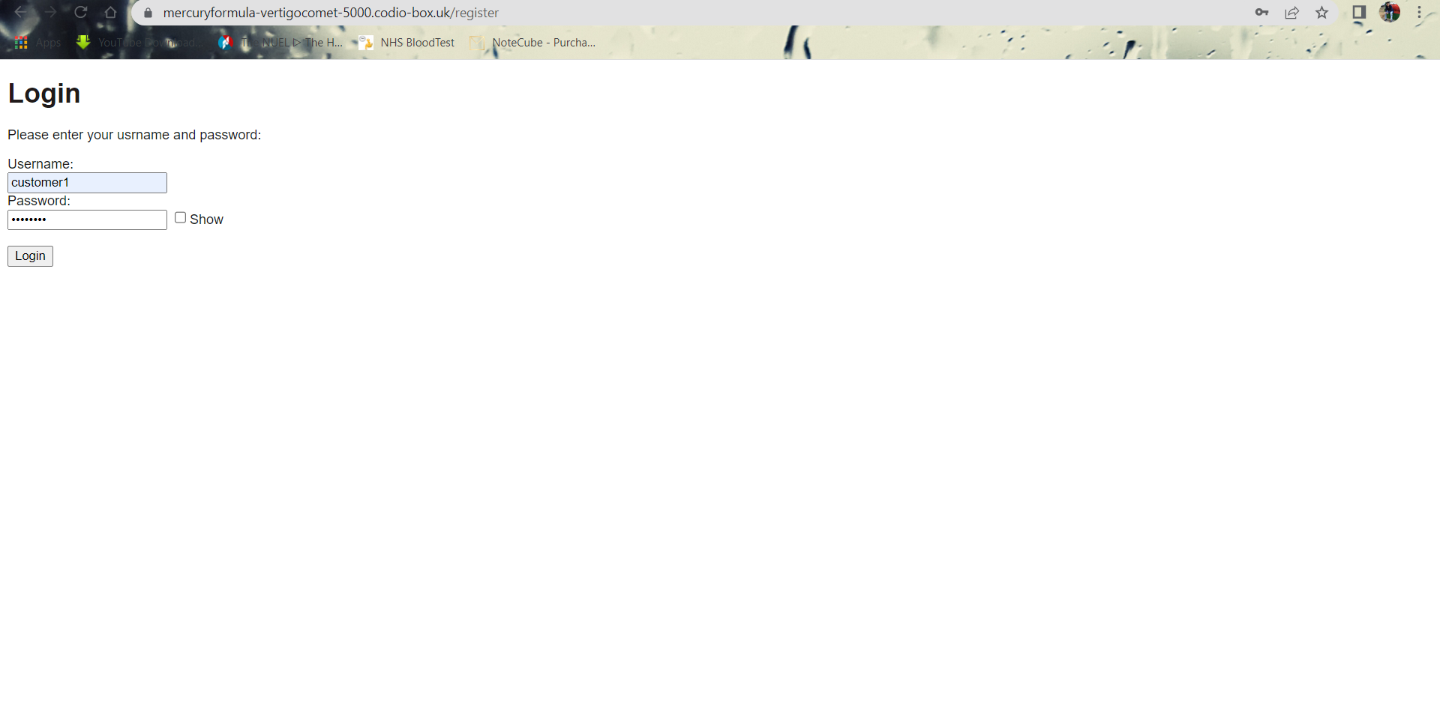

Requires username and password to login.

5.4 Shopfront (15 mins)

.1 System deals with n-sized data

Test 1: Inspect number of database records and cross reference to display. These should match

|  |  |  |  |  |  |
| --- | --- | --- | --- | --- | --- |
| Pass | Yes | Fail | No | Comments | Shows the same number of books for the same number of rows in the books tables in database. |

Test 2: Use alternative database with expanded records and repeat Test 1

|  |  |  |  |  |  |
| --- | --- | --- | --- | --- | --- |
| Pass | Yes | Fail | No | Comments | Both number of records match. |

Test 3: Manually add new data to the database and repeat Test 1

|  |  |  |  |  |  |
| --- | --- | --- | --- | --- | --- |
| Pass | Yes | Fail | No | Comments | Shows the proper amount of books. |

.2 Images are correctly displayed

Test 1: Ensure that images are correctly resized and fit bounding box

|  |  |  |  |  |  |
| --- | --- | --- | --- | --- | --- |
| Pass | Yes | Fail | No | Comments | No issue |

.3 Currencies are correctly displayed

Test 1: interface should display correct symbol for currency ($, £ etc.)

|  |  |  |  |  |  |
| --- | --- | --- | --- | --- | --- |
| Pass | Yes | Fail | No | Comments | Shows the sterling(£) currency as the prices are in GBP. |

.4 Prices are correctly displayed

Test 1: Amounts should agree with database and be formatted in the same way (2 decimal points)

|  |  |  |  |  |  |
| --- | --- | --- | --- | --- | --- |
| Pass | Yes | Fail | No | Comments | The amounts agree with database. |

Examining the database shows there are 10 records:

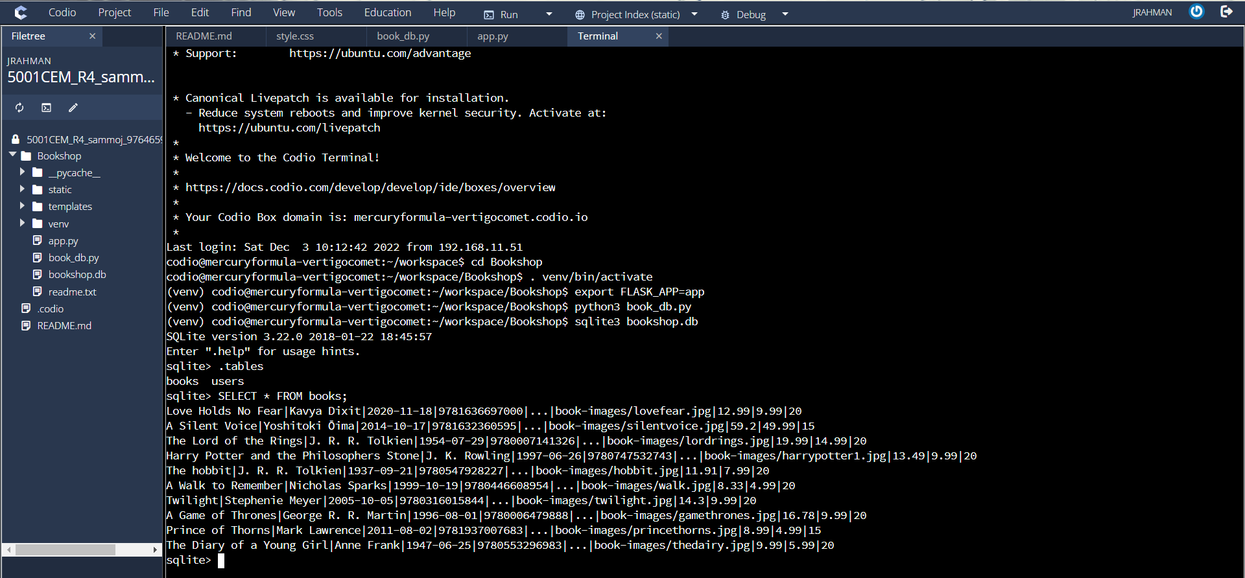 

Running the app correctly shows 10 books on the storefront, and these match the database items.

5.5 Bookshop Cart (5 mins)

.1 Books can be added

Test 1: Add item

|  |  |  |  |  |  |
| --- | --- | --- | --- | --- | --- |
| Pass | Yes | Fail | No | Comments | Add to cart button adds the selected book to the cart. |

.2 Cart system with remove and empty

Test 1: Show cart items

|  |  |  |  |  |  |
| --- | --- | --- | --- | --- | --- |
| Pass | Yes | Fail | No | Comments | The added books are shown in the cart section. |

Test 2: Shows the correct data

|  |  |  |  |  |  |
| --- | --- | --- | --- | --- | --- |
| Pass | Yes | Fail | No | Comments | Shows the correct price and quantity for specified books. |

Test 3: Remove item from the cart

|  |  |  |  |  |  |
| --- | --- | --- | --- | --- | --- |
| Pass | Yes | Fail | No | Comments | Removes the specific book from cart. |

Test 4: Removes all items from cart

|  |  |  |  |  |  |
| --- | --- | --- | --- | --- | --- |
| Pass | Yes | Fail | No | Comments | Empty cart button removes all items from the cart and redirects to main page for books. |

Adds item to cart with correct image, price and quantity:

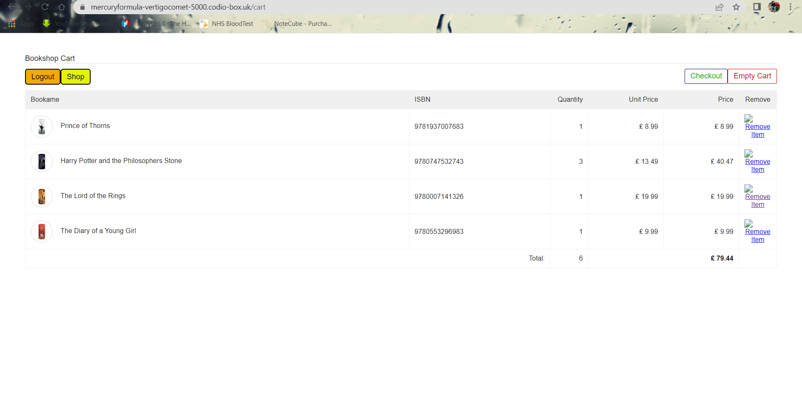

Removes item from cart.

5.6 Admin (7 mins)

.1 Shows the admin specific page

Test 1: Pay for items in basket; payment accept or cancel screen displays

|  |  |  |  |  |  |
| --- | --- | --- | --- | --- | --- |
| Pass | Yes | Fail | No | Comments | Shows the admin page if the user is admin. |

.2 Admin can see the stock page

Test 1: Correct amount of information is displayed

|  |  |  |  |  |  |
| --- | --- | --- | --- | --- | --- |
| Pass | Yes | Fail | No | Comments | The stock button shows the current status of the books in stock. |

Test 2: Every item in stock page requires ISBN

|  |  |  |  |  |  |
| --- | --- | --- | --- | --- | --- |
| Pass | Yes | Fail | No | Comments | ISBN is the primary key. |

.3 Admin can add new books to the existing stock

Test 1: A form asking for data for the new book

|  |  |  |  |  |  |
| --- | --- | --- | --- | --- | --- |
| Pass | Yes | Fail | No | Comments | Can input data for a new book. |

Test 2: Accepts image as input

|  |  |  |  |  |  |
| --- | --- | --- | --- | --- | --- |
| Pass | Yes | Fail | No | Comments | Takes image as input. |

Test 3: The data is added to the database and shows in the stock page

|  |  |  |  |  |  |
| --- | --- | --- | --- | --- | --- |
| Pass | No | Fail | Yes | Comments | Bad gateway. The new data is not added to the database and does not show in the stocks page. Need to adjust the parameters and form input type. |

Test 4: Manually add books

|  |  |  |  |  |  |
| --- | --- | --- | --- | --- | --- |
| Pass | Yes | Fail | No | Comments | Can add books manually to the database which shows in the stock page. |

Shows the admin page with current stock and new added stock:

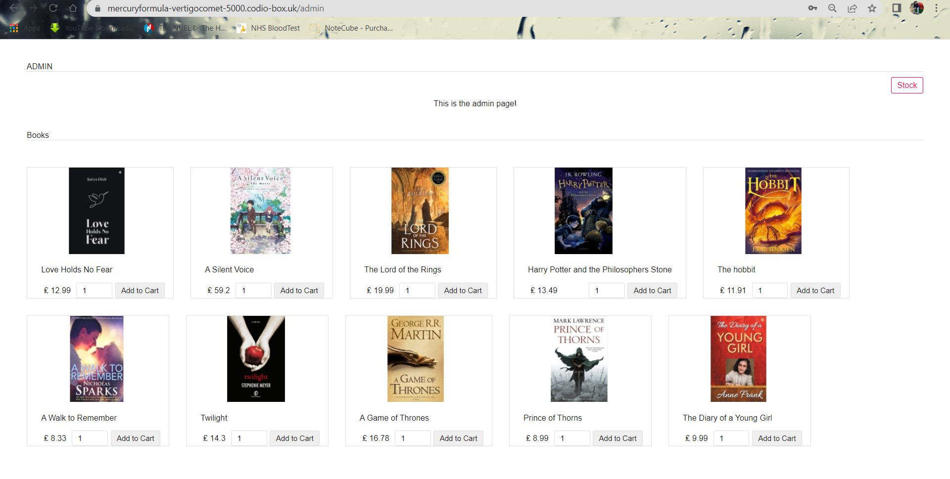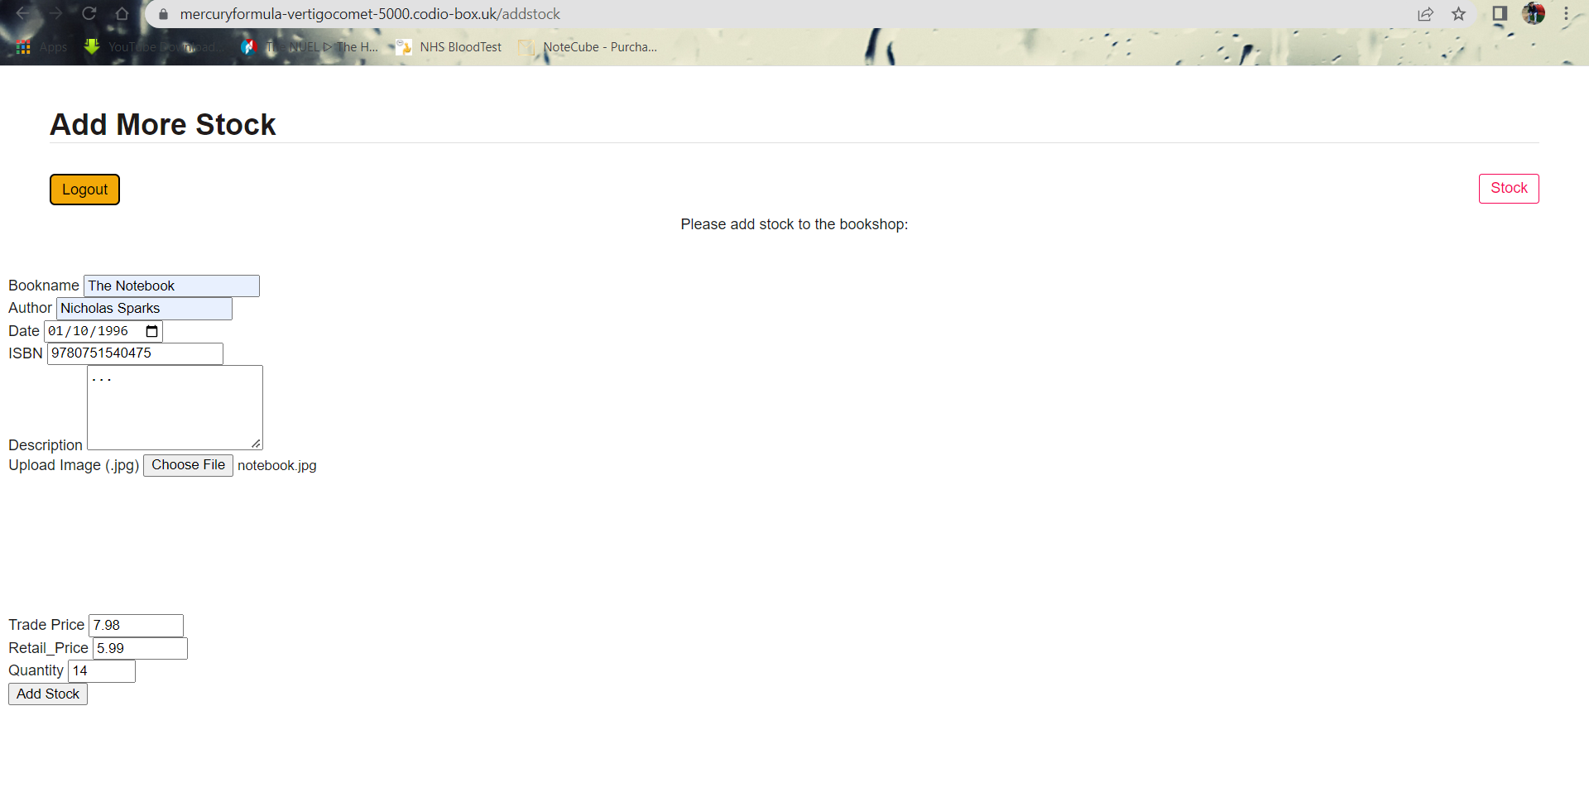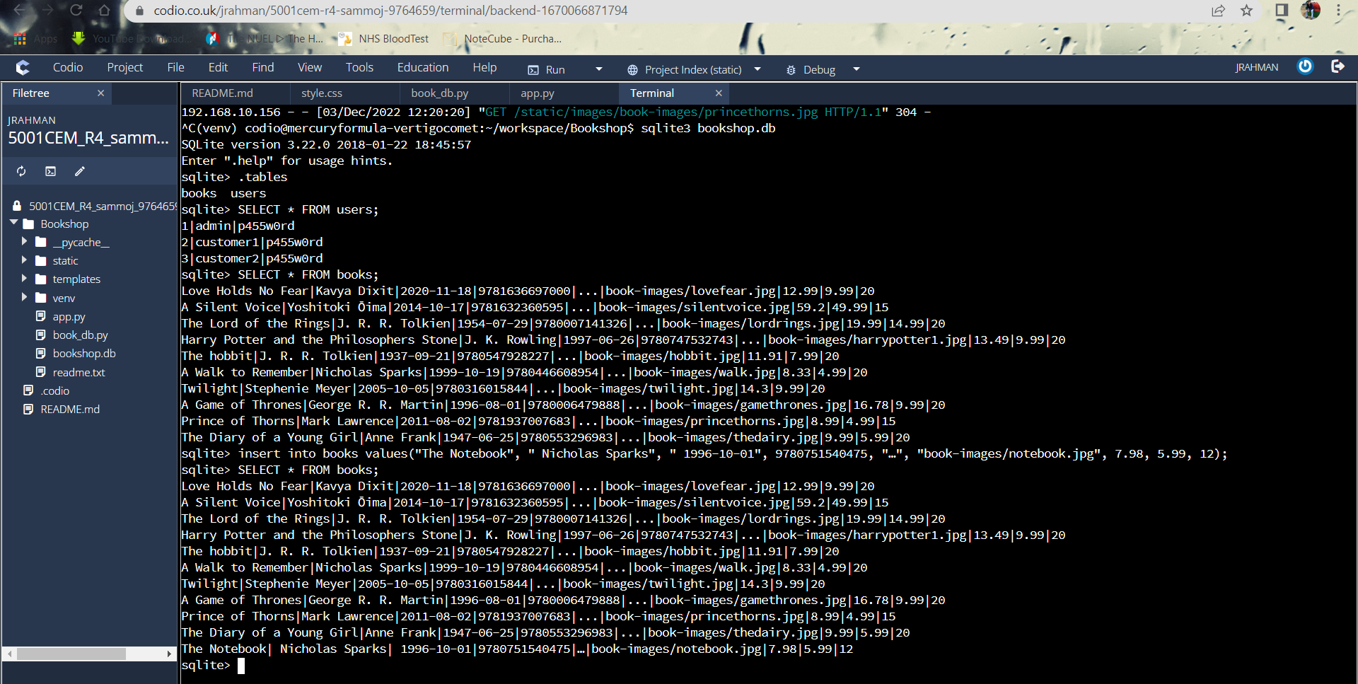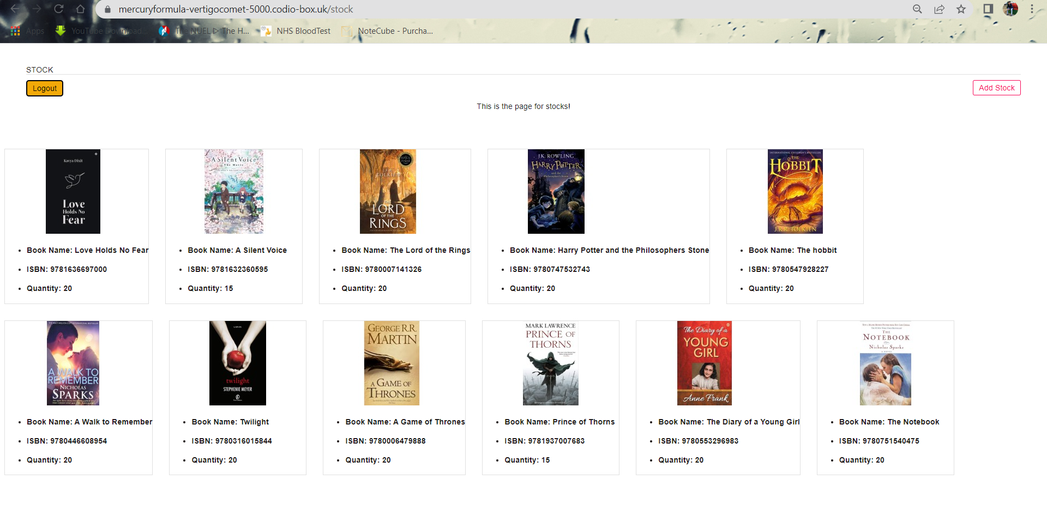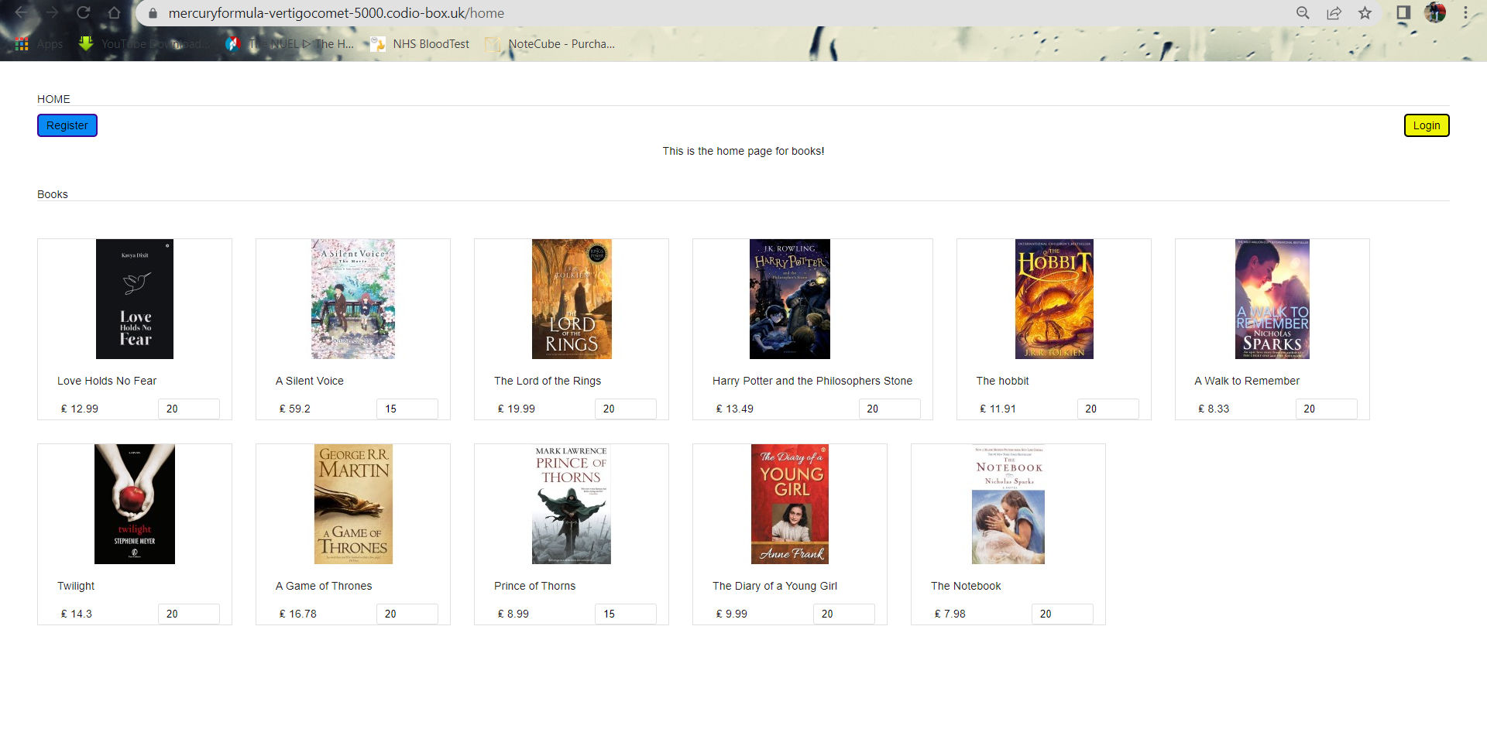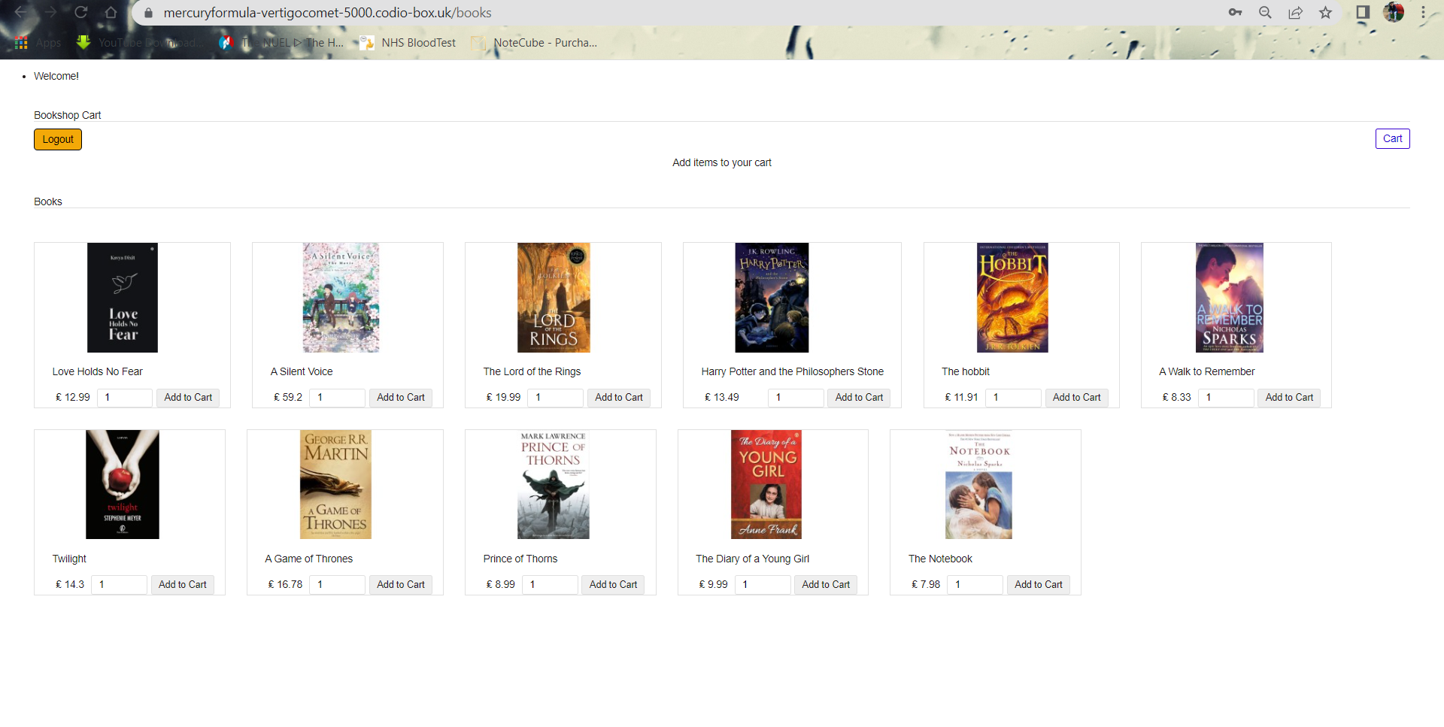

5.7 Checkout (3 mins)

.1 Takes the cart items for checkout and shows proper pricing

Test 1: The quantity and price for the number of amount is shown correct

|  |  |  |  |  |  |
| --- | --- | --- | --- | --- | --- |
| Pass | Yes | Fail | No | Comments | Displays the selected books with their quantity and price. |

Test 2: Calculates posting fee

|  |  |  |  |  |  |
| --- | --- | --- | --- | --- | --- |
| Pass | Yes | Fail | No | Comments | Calculates the right amount of postage-cost for each book. |

Test 3: Total price includes the postage-cost

|  |  |  |  |  |  |
| --- | --- | --- | --- | --- | --- |
| Pass | Yes | Fail | No | Comments | The final price is calculated properly. |

.2 Payment is accepted

Test 1: Pay for items in basket; payment accept or cancel screen displays

|  |  |  |  |  |  |
| --- | --- | --- | --- | --- | --- |
| Pass | Yes | Fail | No | Comments | Shows the dummy payment. |

Checkout option correctly displays the books with quantity, price, postage-cos, and total price:

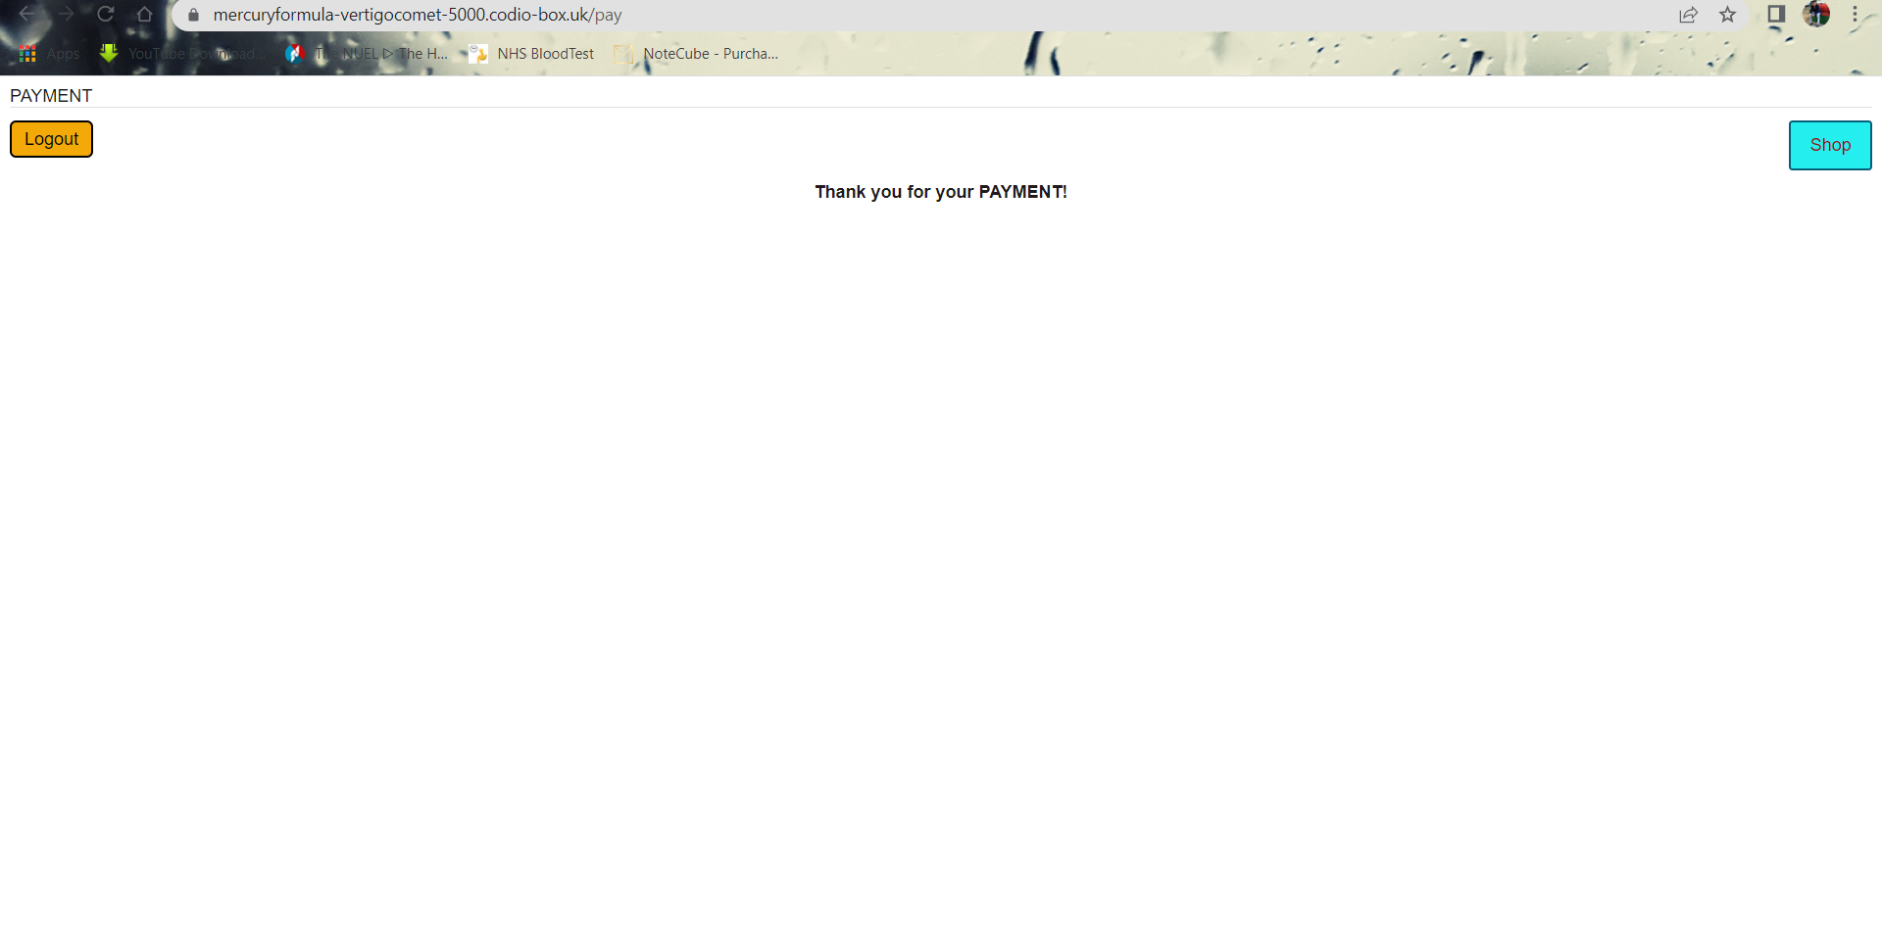

Shows the dummy payment.

1. **QUALITY ASSURANCE**
   * **Brief and requirements delivered on**

The features of the brief are fully implemented. It features ten books as products which can be bought by customers. The database stores ISBN as primary key for the books. The project is a specific bookshop application which is adapted as per the requirements. The system supports user registration and login, stock management, product details, cart add and remove, admin, checkout and payment. The functionalities have been correctly implemented. The payment system uses a dummy payment method for this application.

* + **Coding standards**

The code is clear, simple and organized, so it is easy to understand. It is well-tested and mostly bug-free. The code has been documented and it performs its purpose well. The codebase was adapted from a github repo at < <https://github.coventry.ac.uk/5001CEM-2122/JH_Bookshop.git>> and it is re-usuable which can be further developed. Most of the critical parts of the code have been commented. The project is divided into different parts for better readability and maintainance.

* + **Documentation standards**

The documentation is simple and concise. It has detailed explanation about the code which explains the details on how the code implements the required functionality as well as screenshots to guide through the process. The code installation part describes the setup process while the code explanation part gives a good understanding of the main section of the code and provides an indepth comprehension. The testing also provides a clear view of the test cases and the outcome. It has been properly formatted.

* + **Team details and support**

Not applicable for this placeholder report as all the parts have been completed individually.

* + **Timely delivery**

The code have been uploaded to GitHub repository and the report was submitted to AULA, both delivered by the final deadline as indicated.

1. **DOCUMENTATION**

Documentation included with this project is:

* Commented code at <https://github.coventry.ac.uk/5001CEM-2122/5001CEM_R4_sammoj_9764659>
* Statement of code purpose (Section 1 of this report)
* Statement of code location (Section 2 of this report)
* Code install instructions (Section 3 of this report)
* Code explanation (Section 4 of this report)
* Testing Regime (Section 5 of this report)
* QA Statement (Section 6 of this report)

**REFERENCES**

* AULA -> 5001CEM – Software Engineering – 2122SEPJAN -> Materials by John Halloran

(<https://coventry.aula.education/?#/dashboard/d0f2228a-9eff-445e-953d-ebf4082fa218/journey/materials/20520568-9f24-4d32-a514-394b98fd0910>)

* GitHub organisation (<https://github.coventry.ac.uk/5001CEM-2122>)
* GitHub repository by John Halloran for bookshop (<https://github.coventry.ac.uk/5001CEM-2122/JH_Bookshop.git>)
* Introduction to Flask (<https://pymbook.readthedocs.io/en/latest/flask.html#:~:text=Flask%20is%20a%20web%20framework,application%20or%20a%20commercial%20website>.)